

CELLPHONE CHURN

Predictive modelling



# SUBMITTED BY- SANKALP RAJ MATTA

## CONTENTS

1. Project Objective
2. Data Analysis
   1. Descriptive Data Analysis
   2. Exploratory Data Analysis
      1. Univariate Data Analysis
      2. Bivariate Data Analysis
   3. Summary of the insights from Data Analysis
3. Check for the Integrity of Data
   1. Outlier Detection
   2. Missing value Detection
4. Multicollinearity Detection
   1. Correlation Matrix
5. Logistic Regression
   1. Applying Logistic Regression
      1. Splitting the Data set Into TEST and TRAIN sets
      2. Creating Logistic Models
      3. Variance Inflation Factor
      4. Likelihood
      5. Predictions+ Confusion Matrix On Train Data
      6. Predictions + Confusion Matrix On Test Data
   2. Interpretation Of Logistic Model
6. Other Performance measures on Logistic <KS,AUC,GINI>
   1. Model performance measures on Training Data
      1. AUC by ROC Curve
      2. KS Statistic
      3. GINI
   2. Model performance measures on Testing Data
      1. AUC by ROC Curve
      2. KS Statistic
      3. GINI
   3. Interpretation Of other performance measures
7. KNN Model
   1. Applying KNN Model
   2. Interpretation of KNN Model
8. Naïve Bayes Model
   1. Applying Naïve Bayes
   2. Interpretation of Naïve Bayes
9. Interpretation of the confusion metrices
   1. For Logistic Regression
   2. For KNN Model
   3. For Naïve Bayes

## 1. PROJECT OBJECTIVE

Customer Churn is a burning problem for Telecom companies. In this project, we simulate one such case of customer churn where we work on a data of postpaid customers with a contract. The data has information about the customer usage behavior, contract details and the payment details. The data also indicates which were the customers who canceled their service. Based on this past data, we build various models which can predict whether a customer will cancel their service in the future or not.

## 2.DATA ANALYSIS

It is a culmination of Descriptive and Exploratory Data Analysis. It is done to understand the basic data structure as well as to visualize the dataset before performing any modelling.

It checks for the relationship between the variables through the use of graphs. And also gives the summary and the class of each variable.

### 2.1 DESCRIPTIVE DATA ANALYSIS

str(cellphone) attach(cellphone) colnames(cellphone)[1]<- 'Churn' str(cellphone) summary(cellphone)

Structure of Dataset initially:

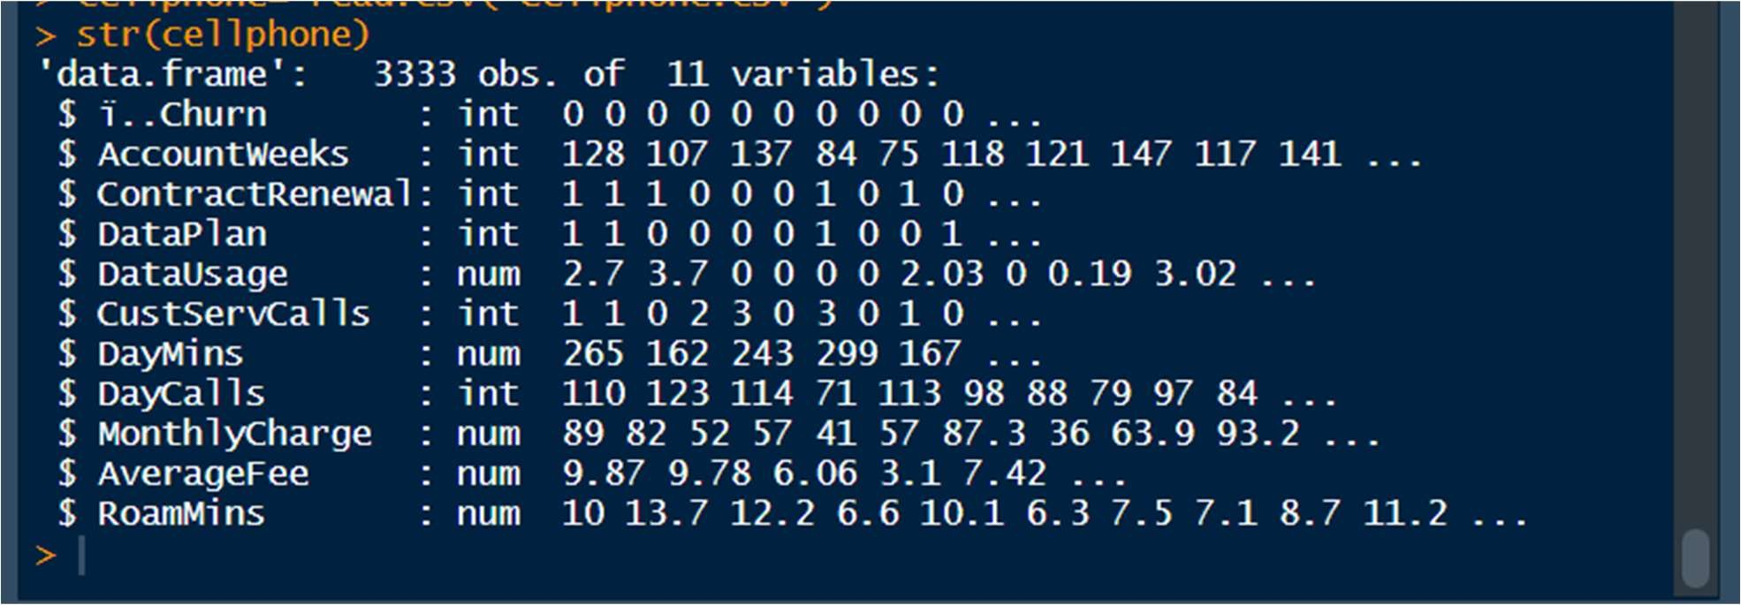

Structure of Dataset after amendments:

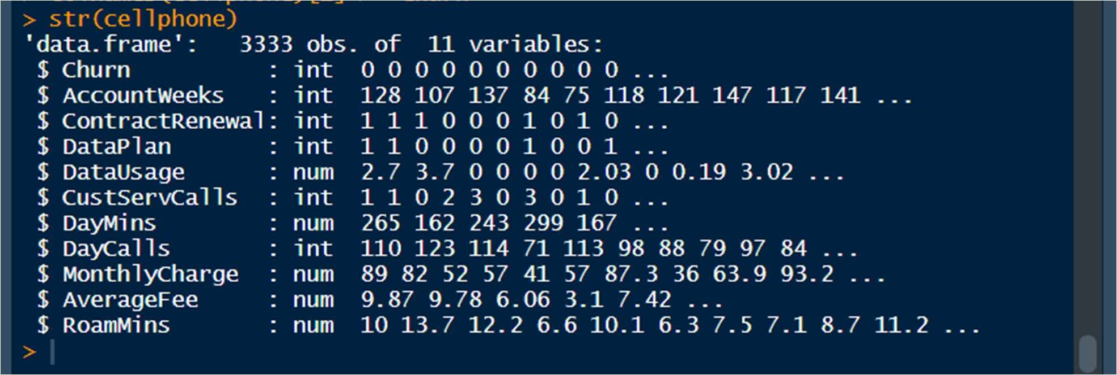

Summary Of Dataset:

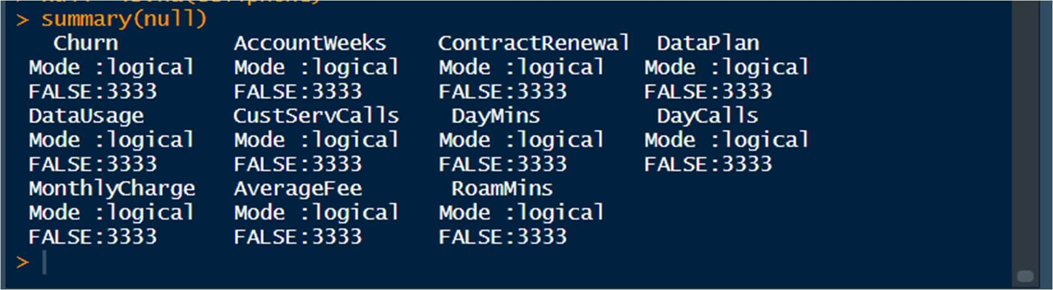

describe(cellphone) dim(cellphone) head(cellphone,10) tail(cellphone,10) describe- decribes all the variables individually giving a superficial idea.

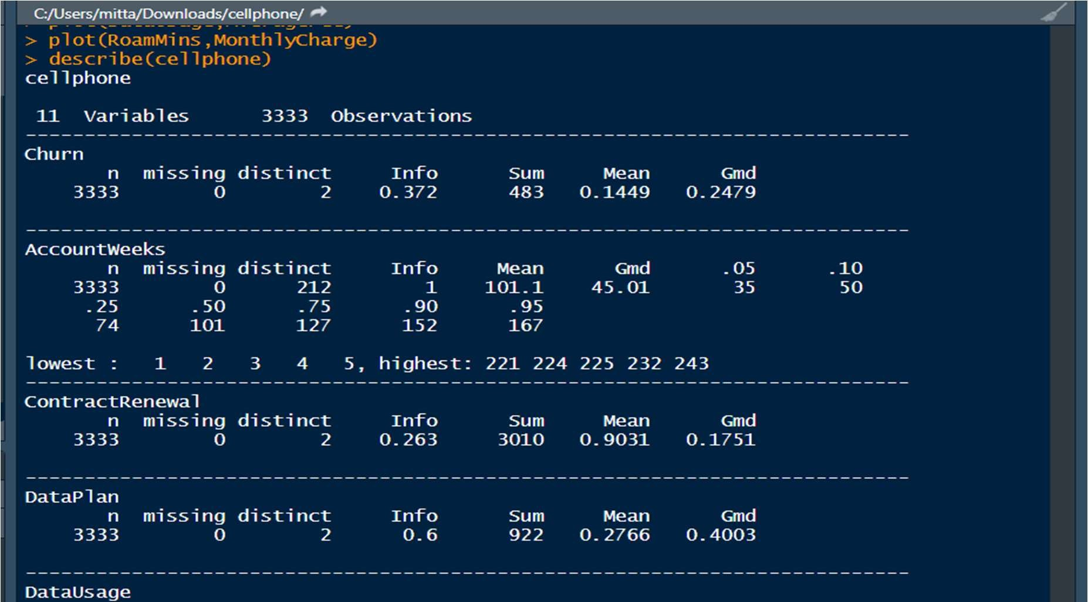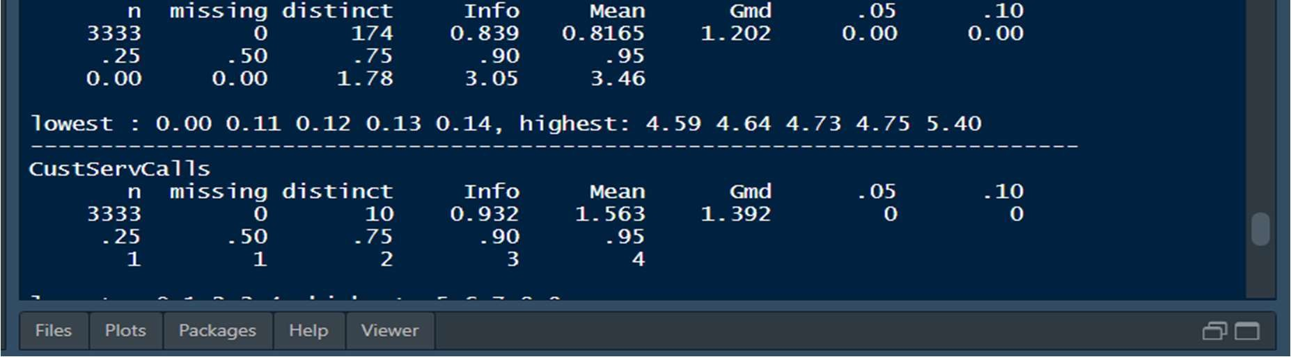

Dim- will tell the dimension of our dataset



Head- will fetch the first 10 records of the dataset

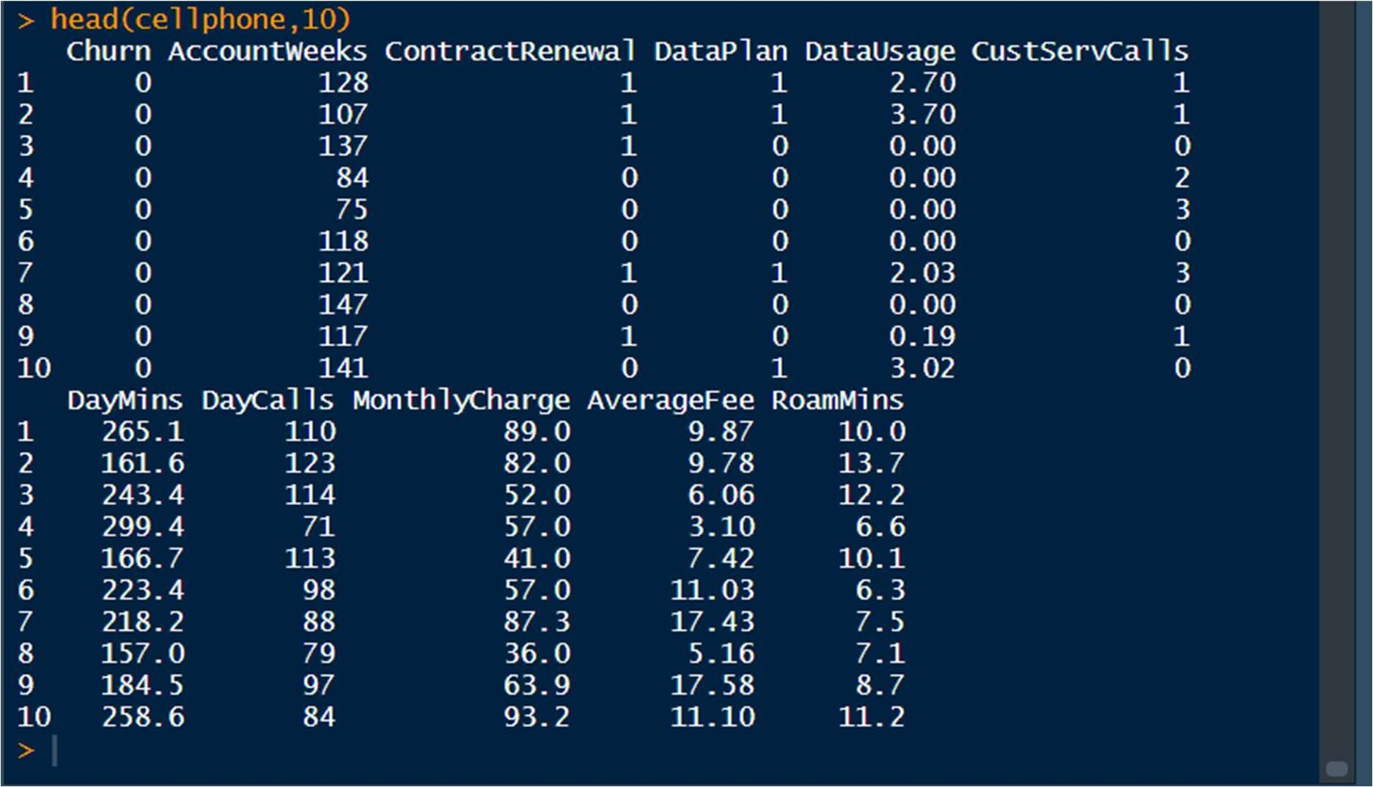

Tails- will fetch the last 10 records of the dataset

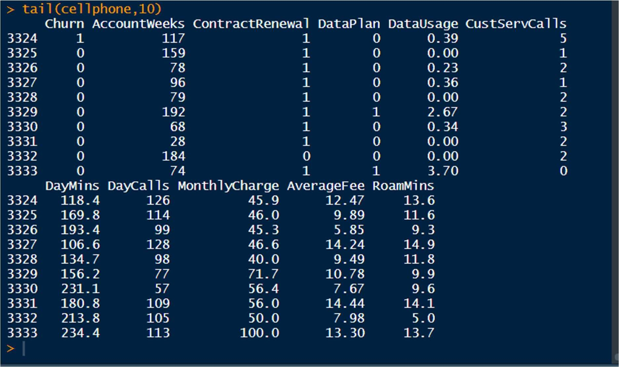

Name of all columns

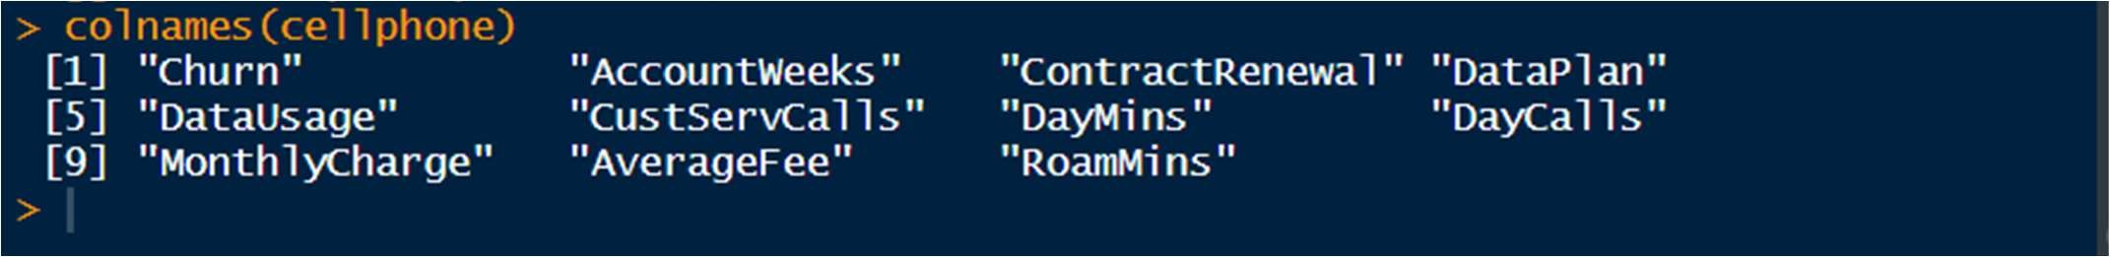

#### 2.2.1 UNIVARIATE ANALYISIS

Done for both categorical and continuous variables

Must be numeric for histogram plotting

##### *HISTOGRAM

hist(DataUsage)

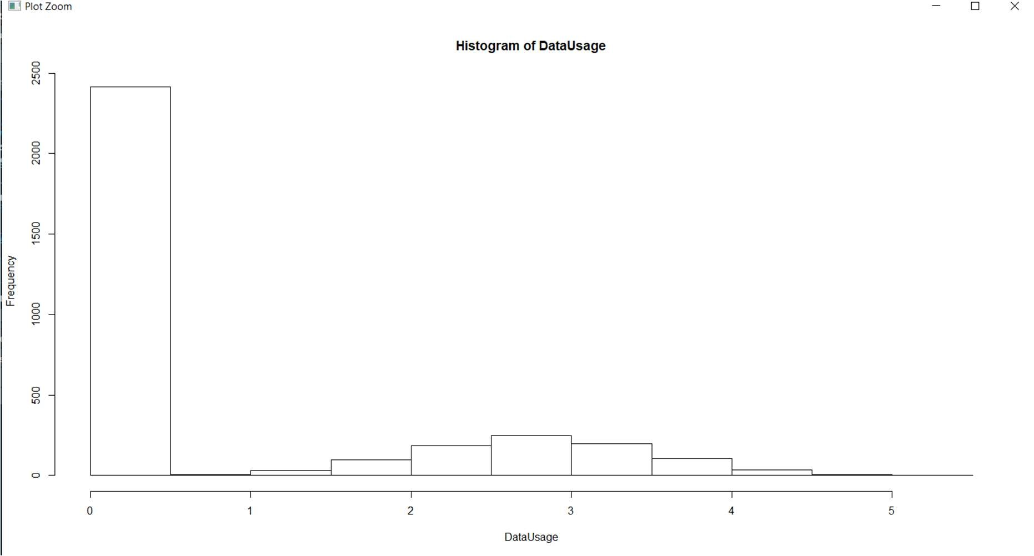

hist(AverageFee)

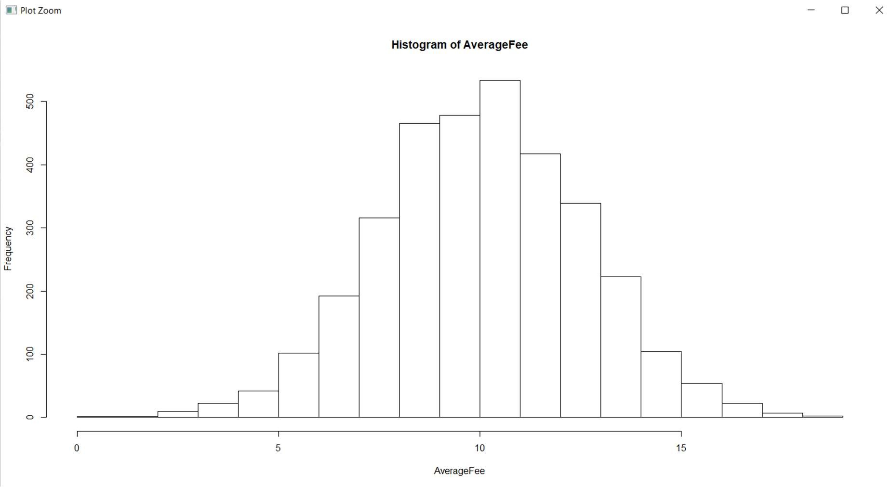

hist(MonthlyCharge)

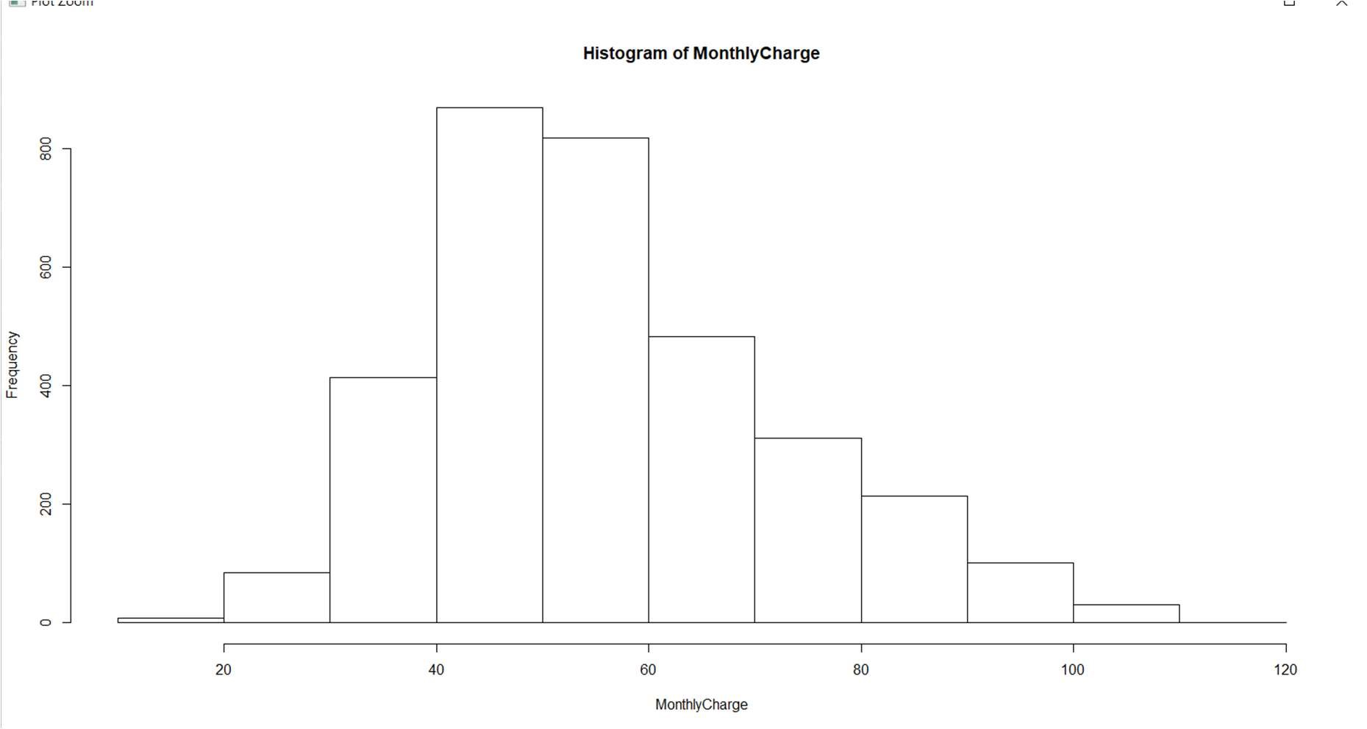

hist(RoamMins)

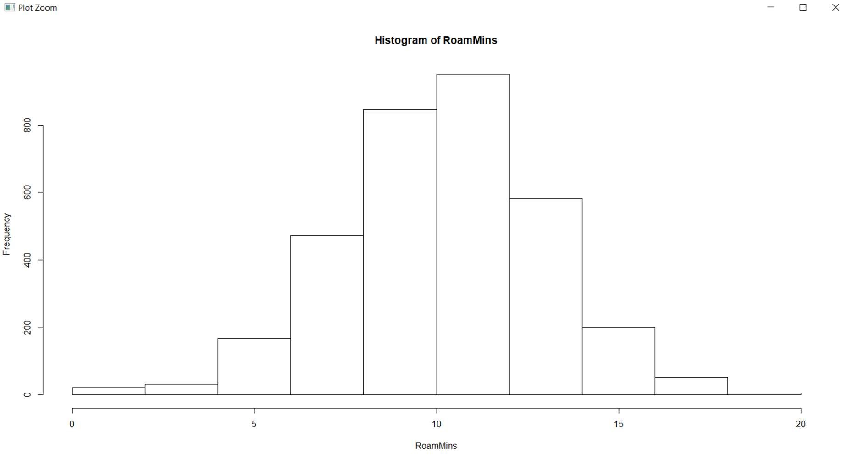

hist(DayMins)

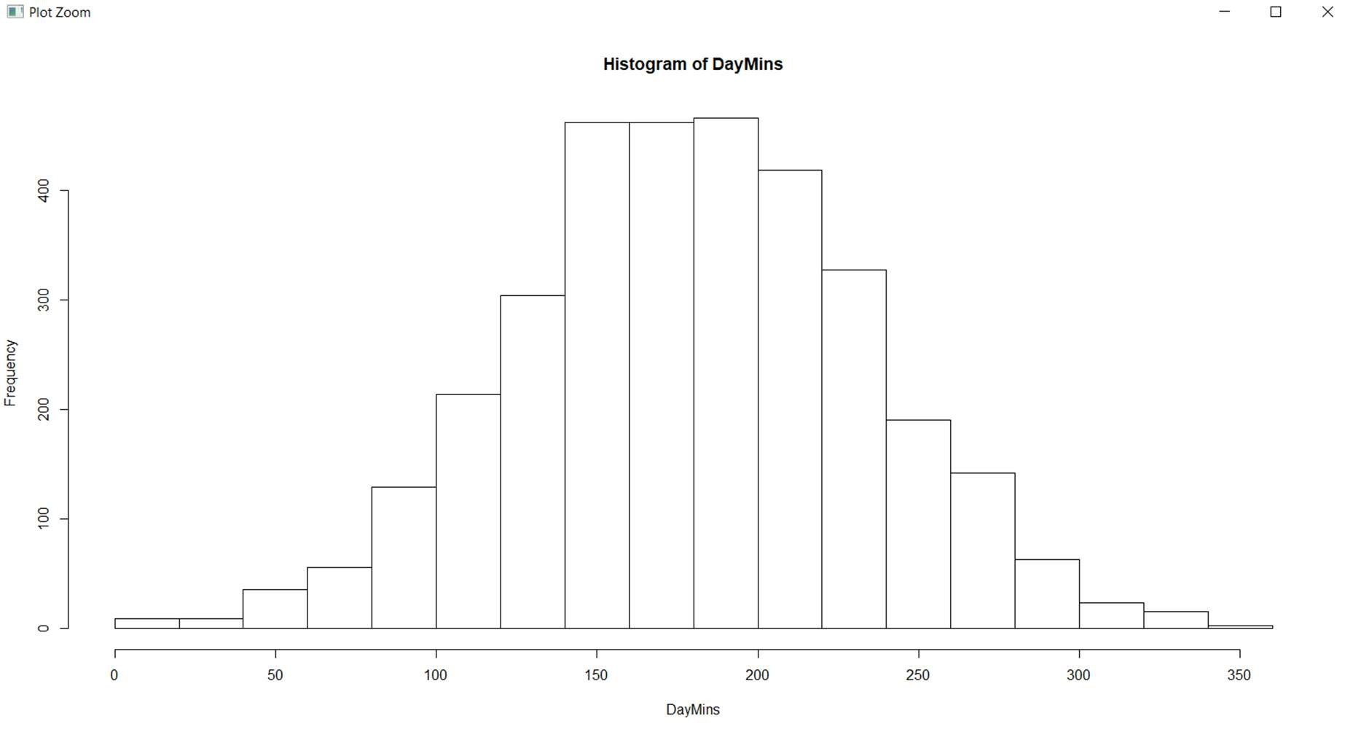

We see that the variables:

AverageFee , RoamMins are normally distributed

##### *BOXPLOT

boxplot(cellphone)

This function will make the boxplots of all the variables individually on a single chart.

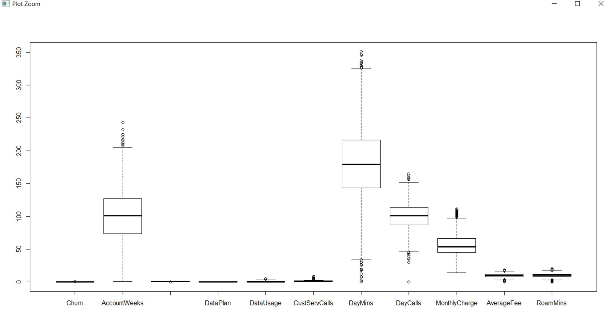

#### 2.2.2BIVARIATE ANALYSIS

By default these plots will be scatterplots(for bivariate numerical variables).

plot(DayMins,DayCalls)

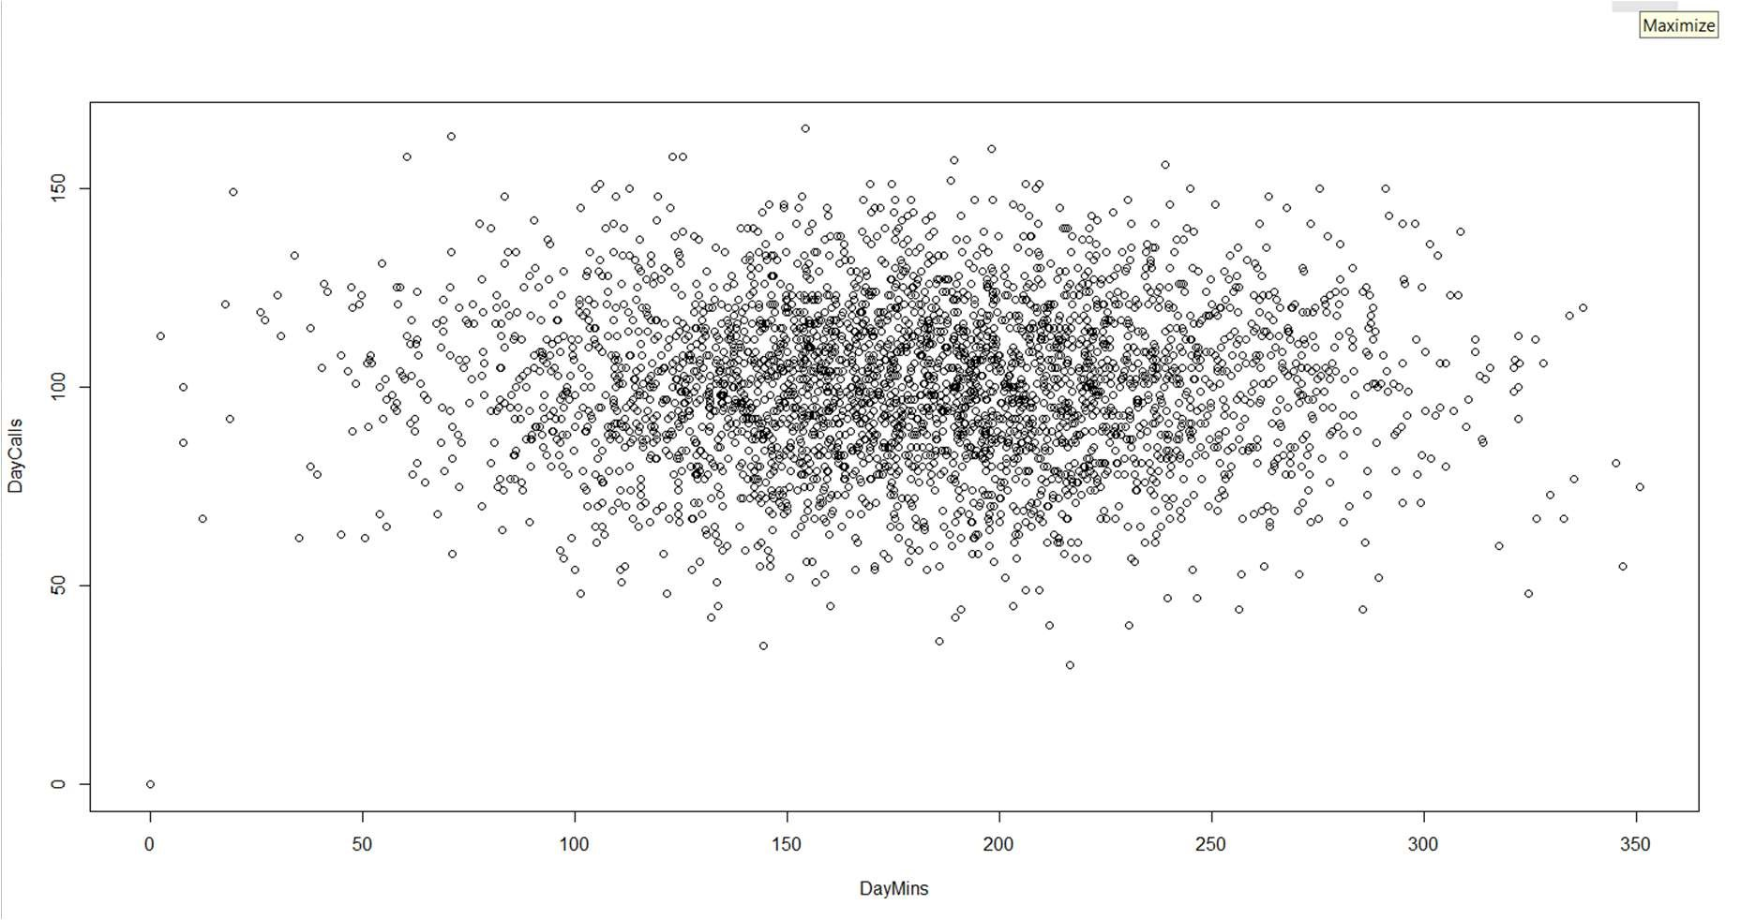

qplot(DataPlan,fill=DataUsage,data=cellphone, geom="bar", main = "Dataplan Vs Data Usage", xlab = "Data Plan", ylab = "Data Usage")

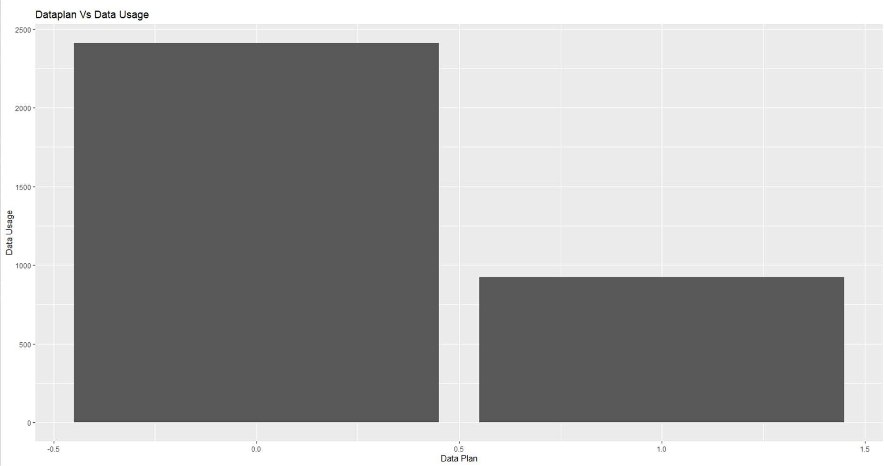

plot(DataUsage,MonthlyCharge)

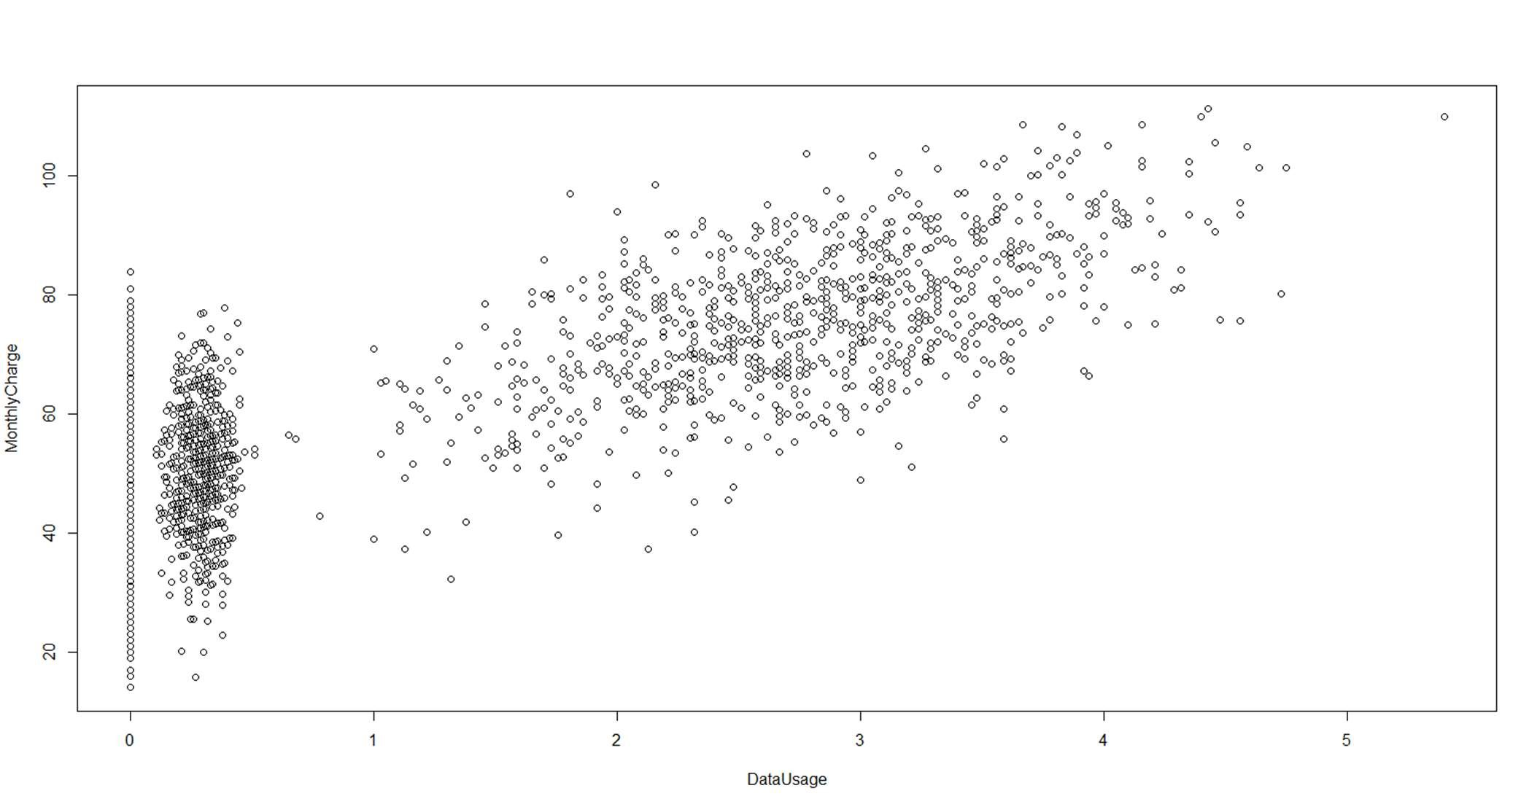

plot(DataUsage,AverageFee)

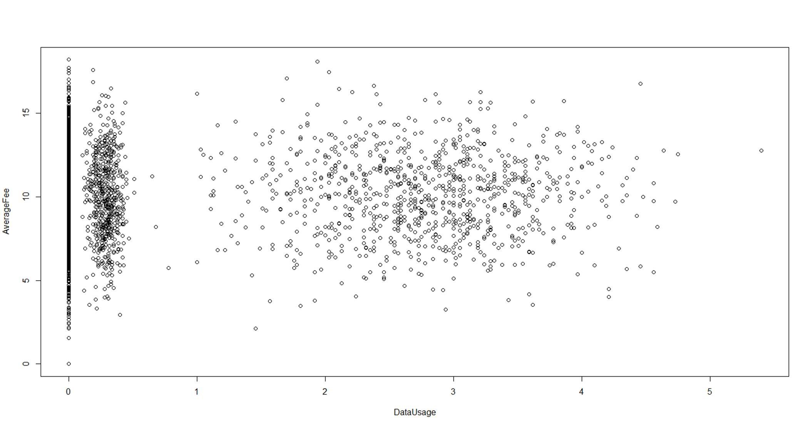

plot(RoamMins,MonthlyCharge)

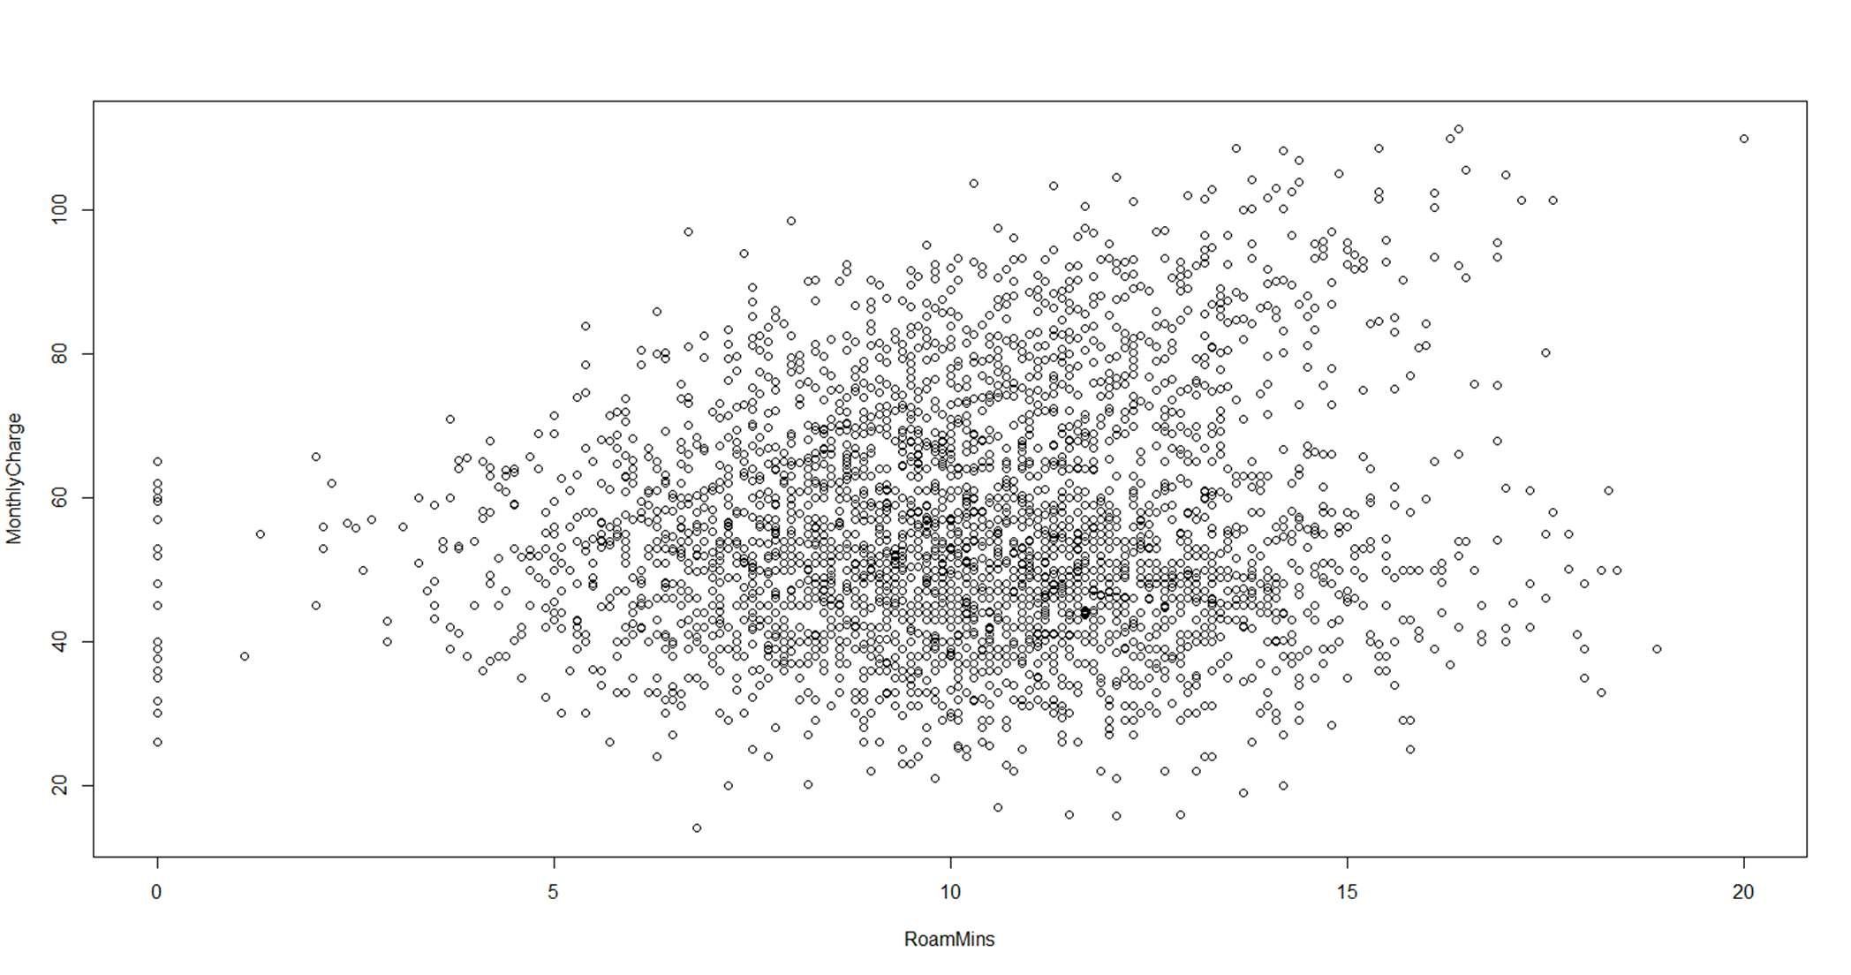

#### 2.3SUMMARY OF THE INSIGHTS FROM DATA ANALYSIS

The data consists of all numeric and integer variables.

*There is the issue of multicollinearity amongst the variable

*There are outliers in certain variable rows

*There are no missing values in the data set

*The predictor variables/independent variables are:

"AccountWeeks" "ContractRenewal" "DataPlan" "DataUsage"

"CustServCalls" "DayMins" "DayCalls"

"MonthlyCharge" "AverageFee" "RoamMins"

*The Dependent variable is : Churn

## 3.CHECKING FOR THE INTEGRITY OF THE DATA

### 3.1 OUTLIER DETECTION USING BOXPLOT BOXPLOT

Depicts that there are outliers in our data. These plots are being made after seeing the correlation matrix and thus, figuring out which variables are to an extent related to each other and then we can visualize their relationship.

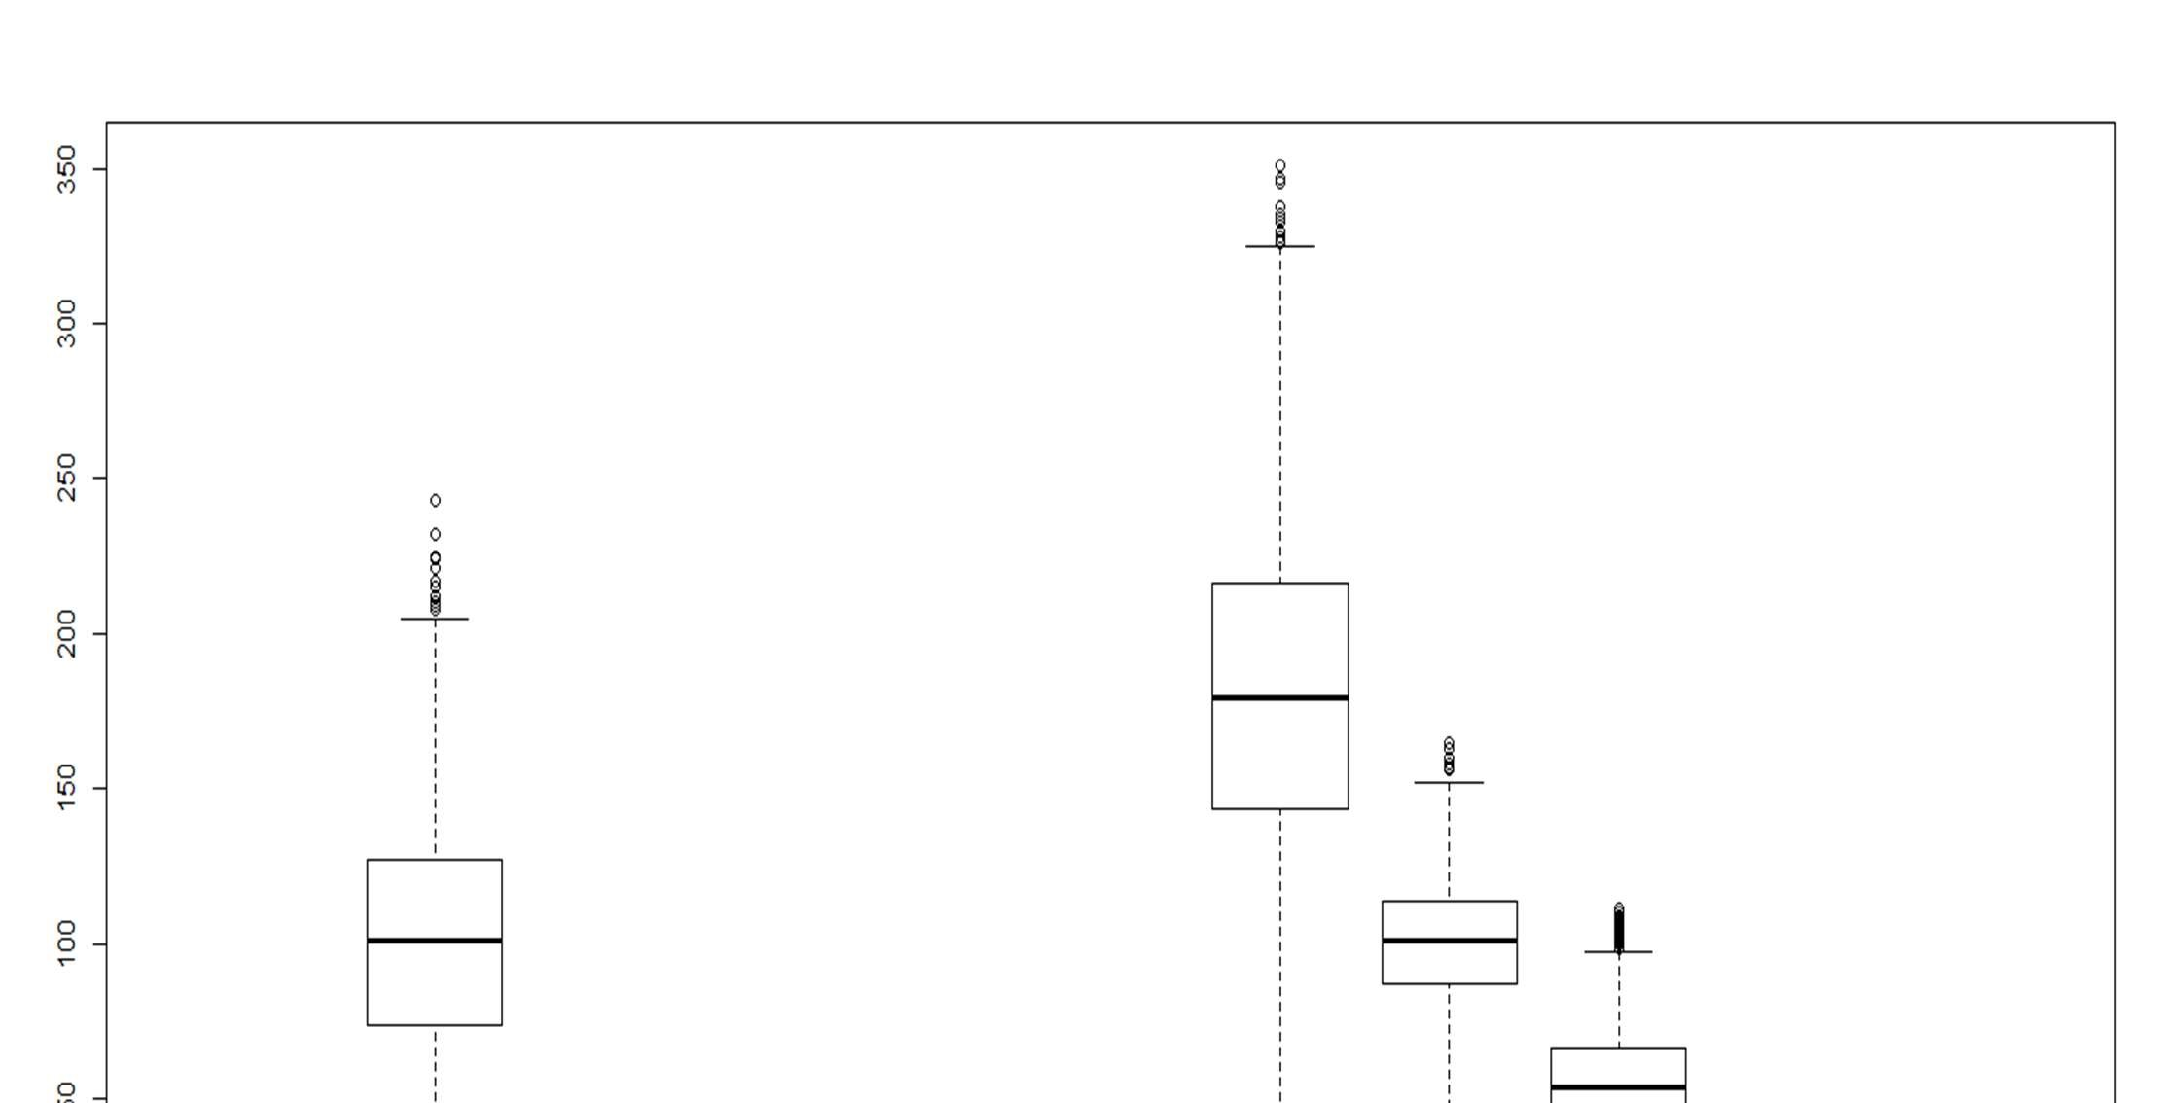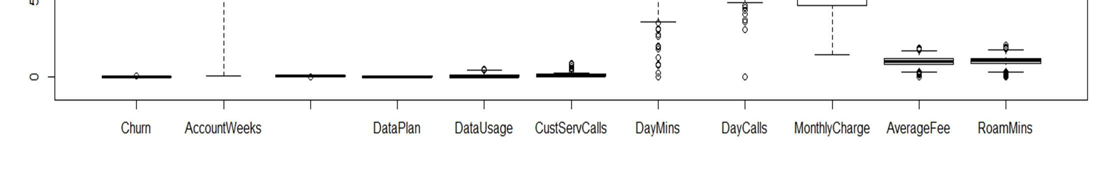

There are outliers in - Accountweeks, DayMins, DayCalls, MonthlyCharge, AverageFee,RoamMins

### 3.2MISSING VALUE DETECTION

null= is.na(cellphone) summary(null) #OR

colSums(is.na(cellphone))

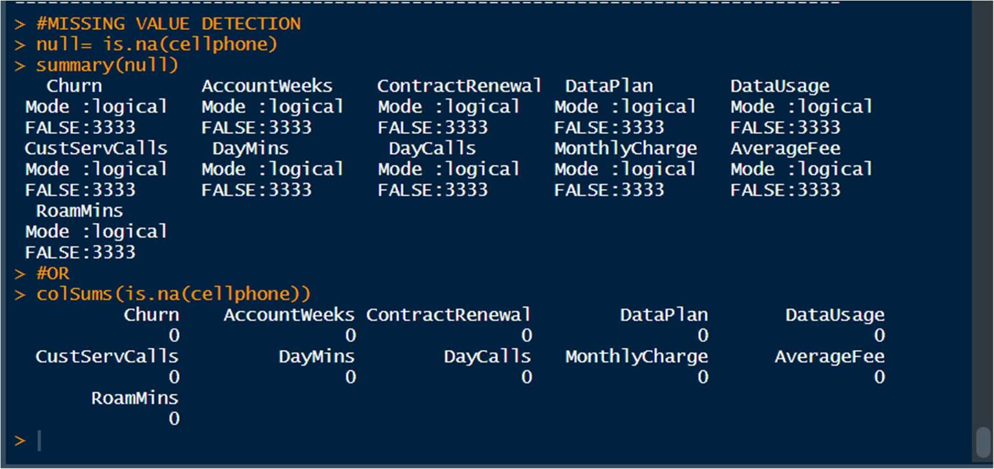

There are no missing values in our dataset

Summary of the dataset

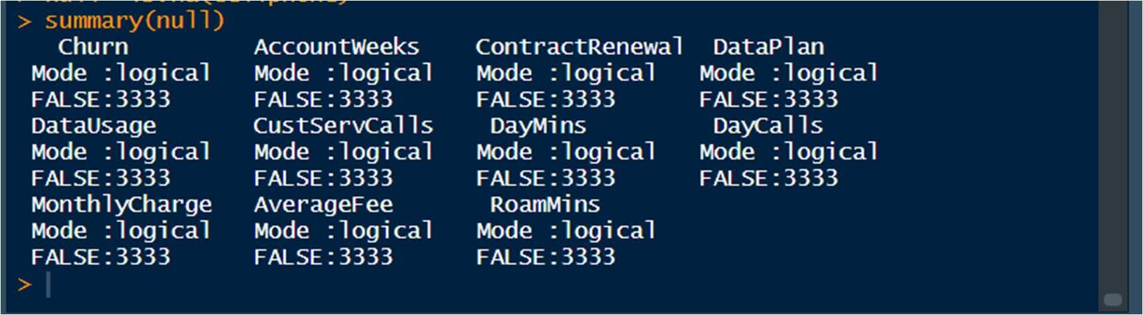

### 4.MULTICOLLINEARITY DETECTION

Multicollinearity occurs when two or more predictors in a regression equation are correlated.

We should not treat multicollinearity because right now logistic regression does not get affected by it. Although we could perform PCFA in order to reduce the variables and group the similar and highly correlated variables together to form a single variable.

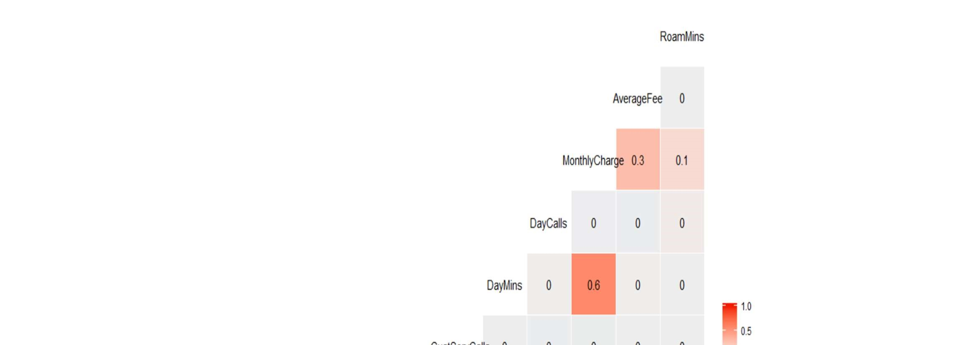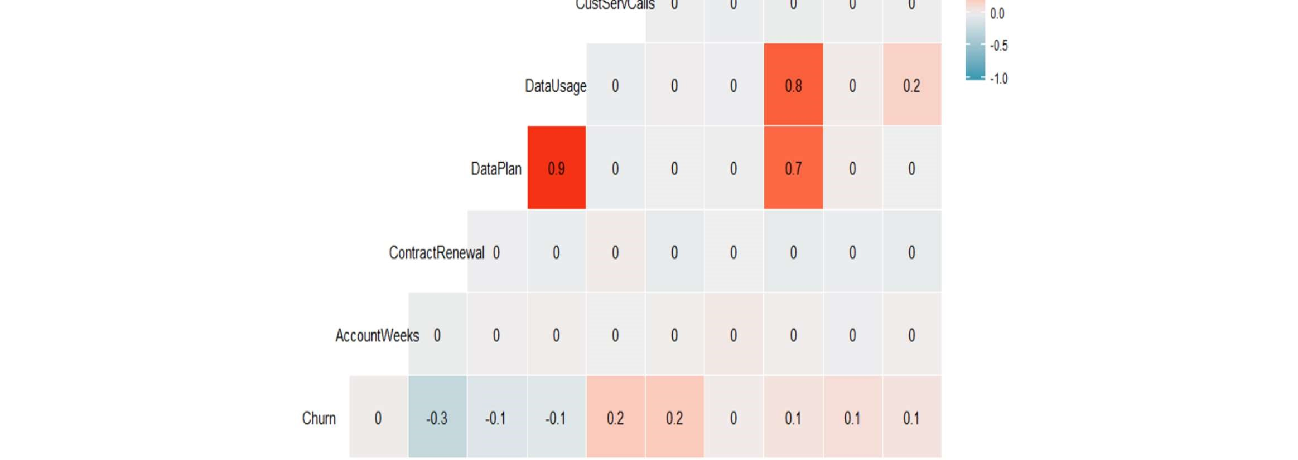

There is multicollinearity between 5 variables- Data Plan, Monthly Usage, Monthly Charge,Data Usage, Data mins

## 5. LOGISTIC REGRESSION MODEL

### 5.1 APPLYING LOGISTIC REGRESSION

#### 5.1.1 Spliting The Dataset Into A Train And Test Data Parts

set.seed(1) split = sample.split(cellphone$Churn, SplitRatio = .70)

Dividing the dataset into Training and Testing sets.

cell.train= subset(cellphone, split== TRUE) cell.test= subset(cellphone,split== FALSE)

Finding the dimensions of the Training and the Testing Dataset dim(cell.train) dim(cell.test)



Baseline Accuracy prop.table(table(cellphone$Churn))

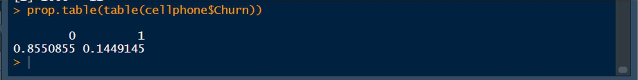

#### 5.1.2 Creating Logistic Regression Models

##### *LOGISTIC REGRESSION - MODEL 1

train.lm1= glm(cell.train$Churn~., data = cell.train,family = binomial ) summary(train.lm1)

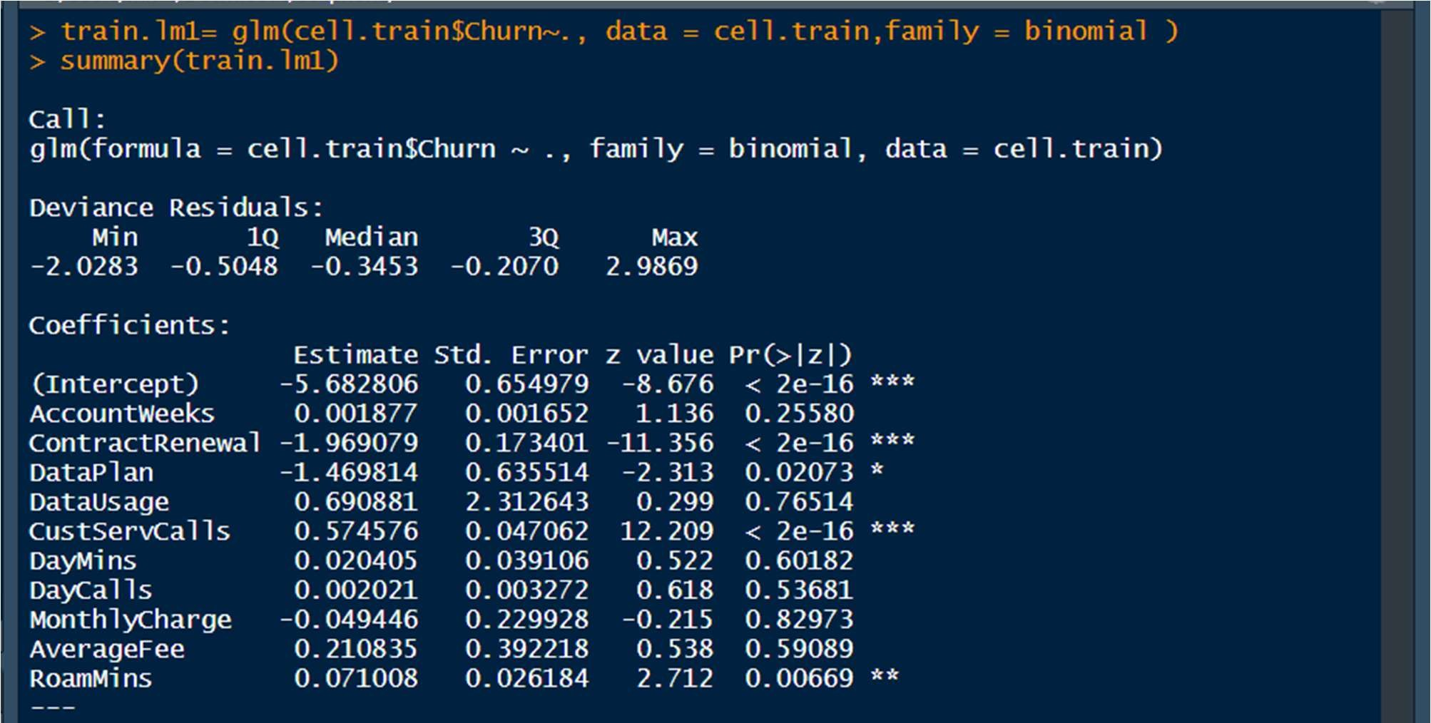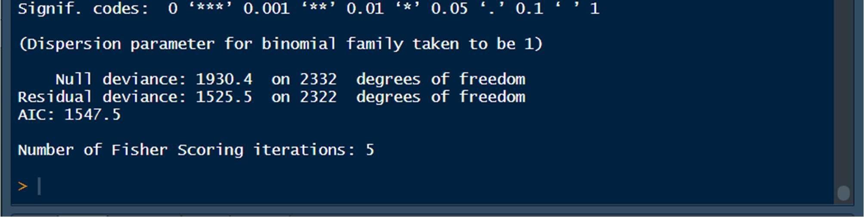

###### Multicollinearity Check for Model1

vif(train.lm1)

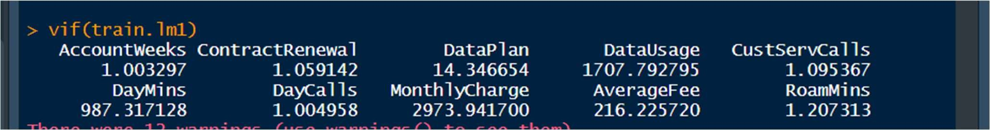

This shows that the variables have multicollinearity problem DataPlan , DataUsage, DayMins, MonthlyCharge, and AverageFee are the correlated variables.

The Relationship between the variables has lead to a an inflation in their variances which means an instability in the coefficient itself.

Here, We see that AccountWeeks, ContractRenewal,DataPlan, CustServCalls and RoamMins

are significant predictor of Churn.

Therefore, we will make another logistic regression model, this time without Data Usage Monthly charge(these two are highly correlated variables)

##### *LOGISTIC REGRESSION MODEL-2

train.lm2= glm(cell.train$Churn~AccountWeeks+ContractRenewal+DataPlan+CustServCalls+ DayMins+DayCalls+AverageFee+RoamMins, data = cell.train,

family = binomial)

summary(train.lm2)

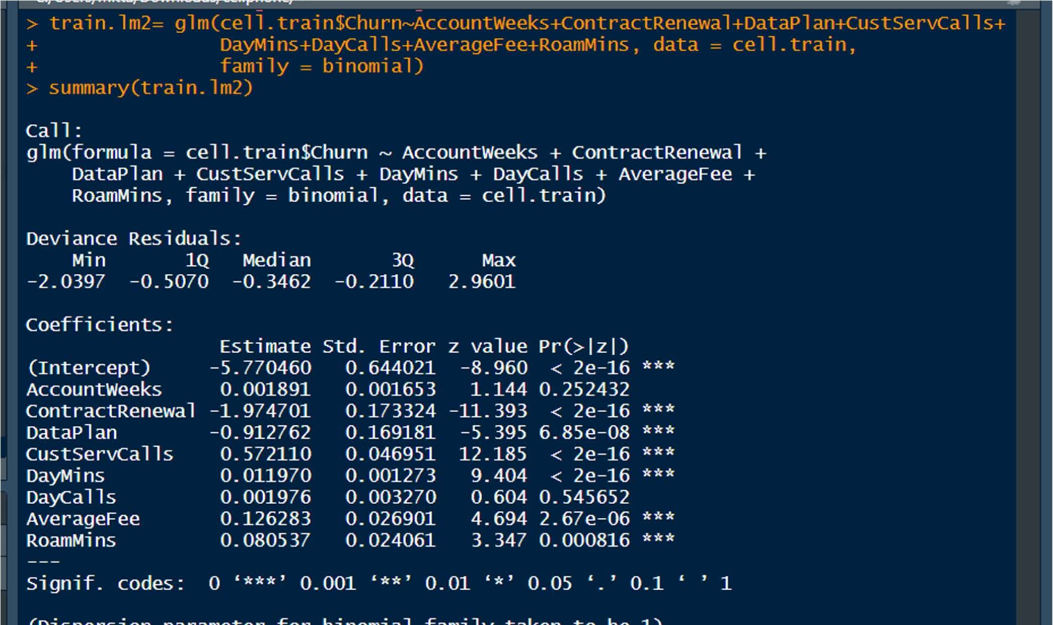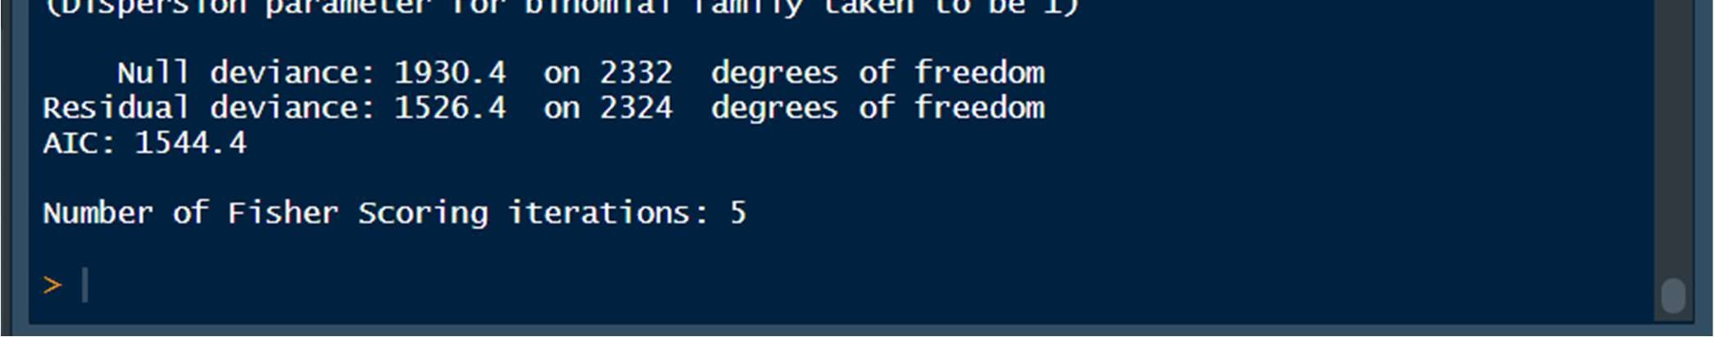

We see that,ContractRenewal,DataPlan, CustServCalls, DayMins,AverageFee and RoamMins are significant predictors of Churn.

###### Relationship between DataUsage and MonthlyCharge plot(DataUsage,MonthlyCharge)

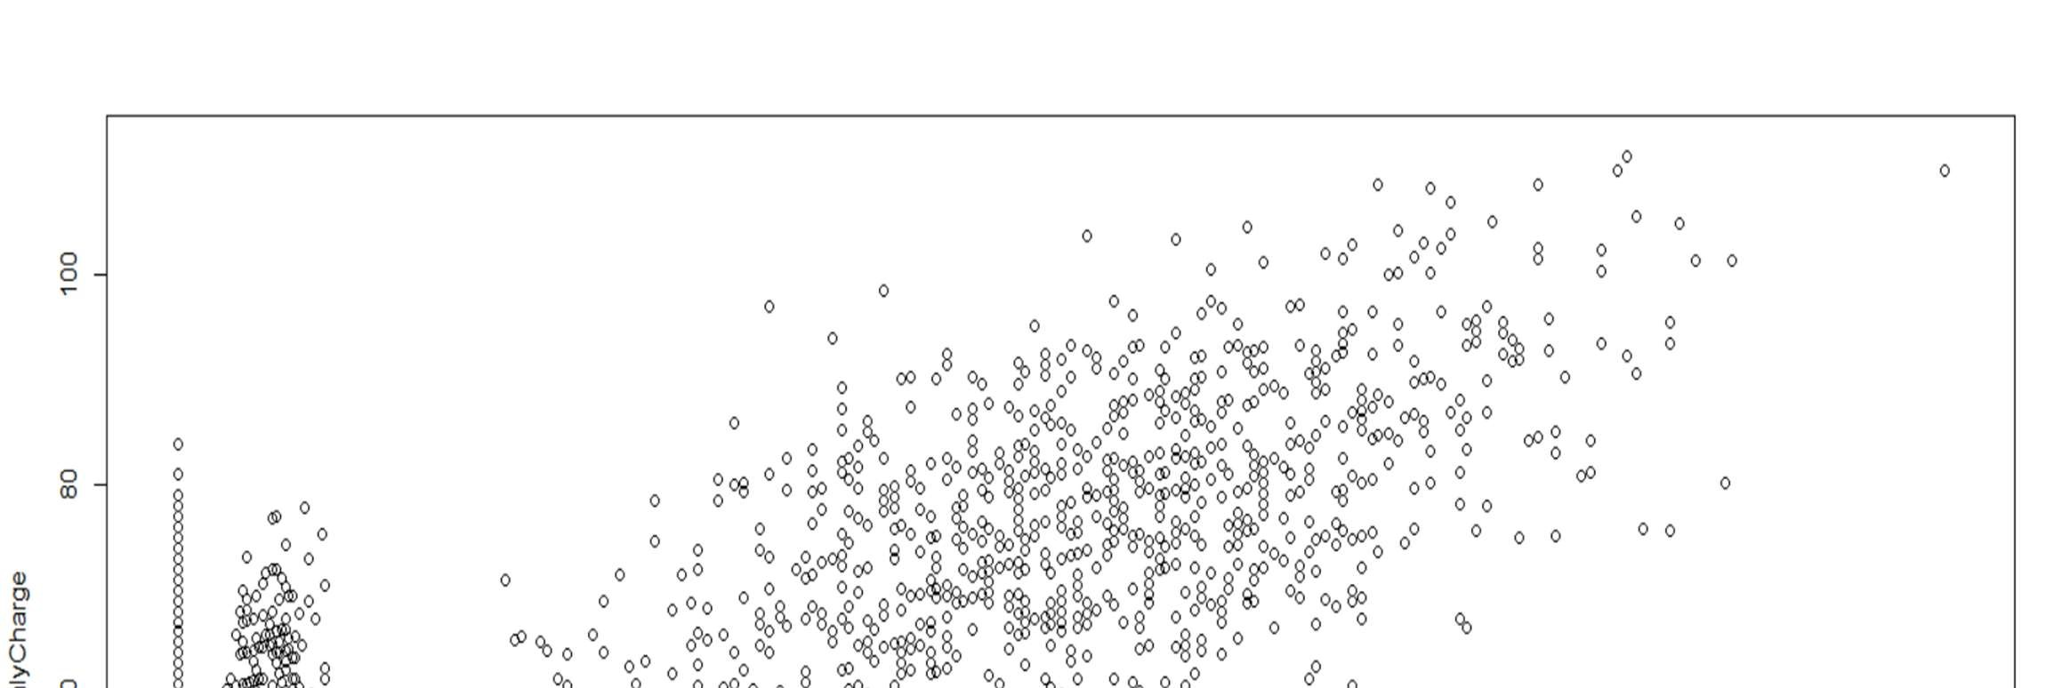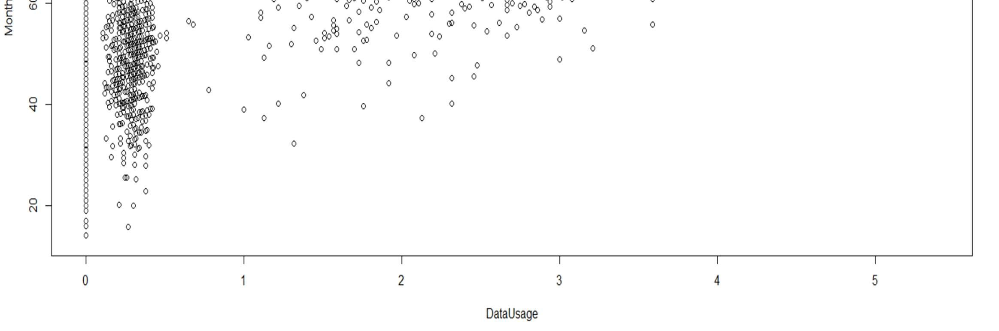

This plot shows how closely related are these variables to each other.

We see that except for AccountWeeks and DayCalls , every other variable is significant.So, removing these 2 variables

Therefore, we create a final Regression model

##### *LOGISTIC REGRESSION MODEL-FINAL

train.lm.final=glm(cell.train$Churn~ContractRenewal+DataUsage+CustServCalls+DayMins+AverageFee+RoamMins,data=cell. train,family = binomial())

summary(train.lm.final)

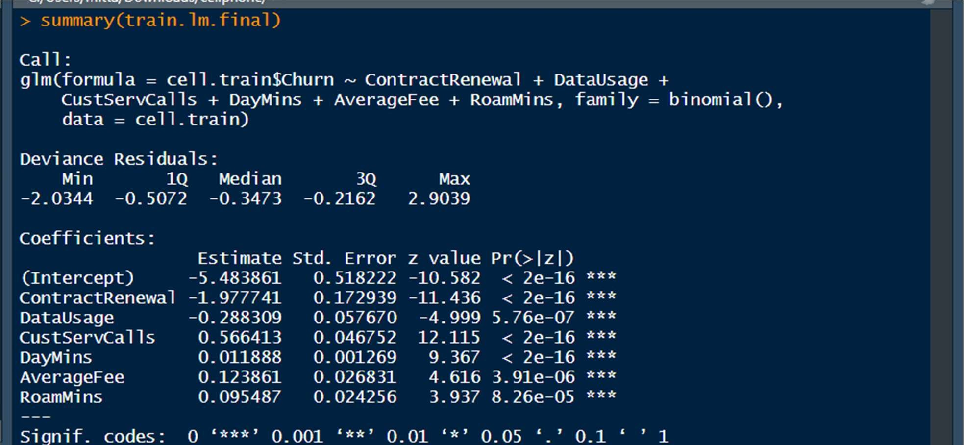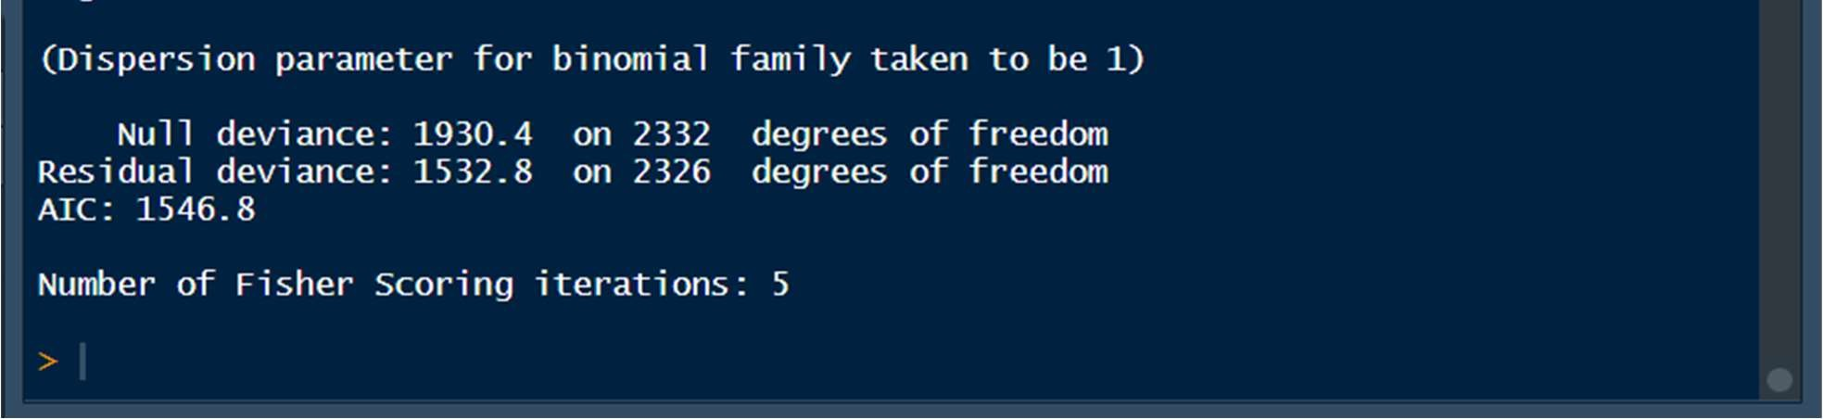

##### 5.1.3 Variance Inflation Factor

vif(train.lm.final)

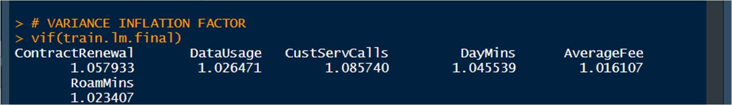

Now, for the final model, there is no high variance inflation for any variables.

##### 5.1.4 LIKELIHOOD

This is used for finding the odds ratio

train.lm.final$coefficients

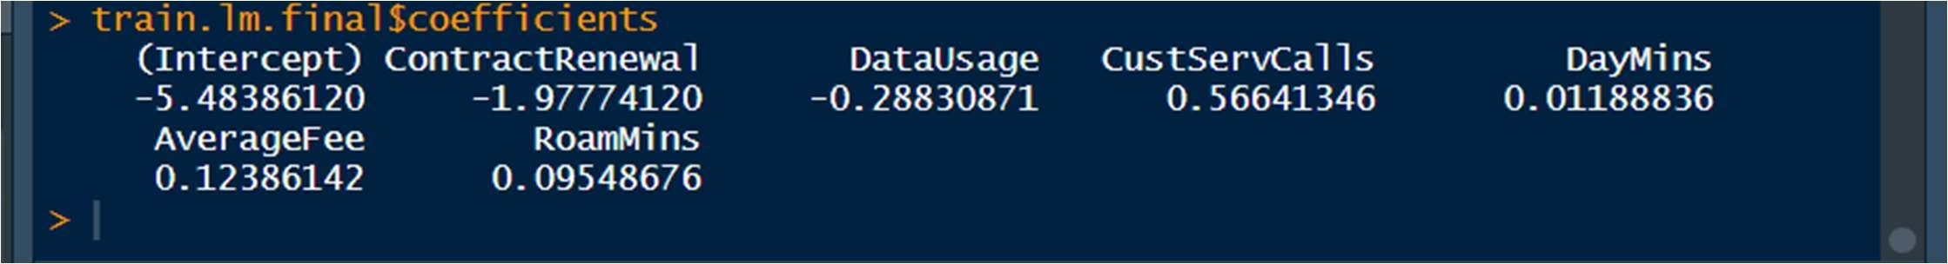

likelihood<- exp(train.lm.final$coefficients) likelihood

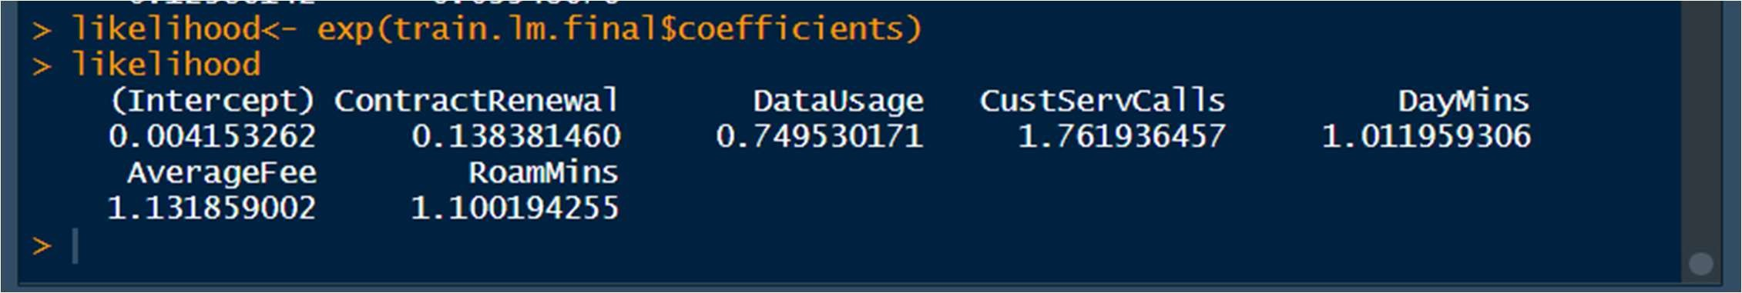

1.7619 is the ODDS RATIO for CustServCalls

We can interpret that for 1 unit increase in CustServCalls , the churn increases by .7619%

##### 5.1.5 Predictions + Confusion Matrix on Train Data

predict.train= predict(train.lm.final, type = "response", data = cell.train) predict.train

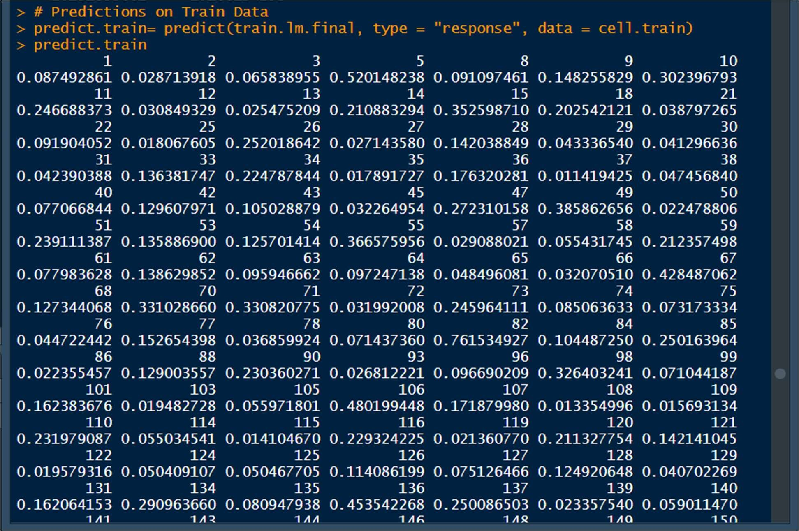

###### CONFUSION MATRIX FOR TRAINING DATA

pred_train1<- ifelse(predict.train>0.5,1,0) str(pred_train1)

->Converting into factors pred_train1<- as.factor(pred_train1) actuals<- as.factor(cell.train$Churn) str(actuals) confusionMatrix(pred_train1,actuals)

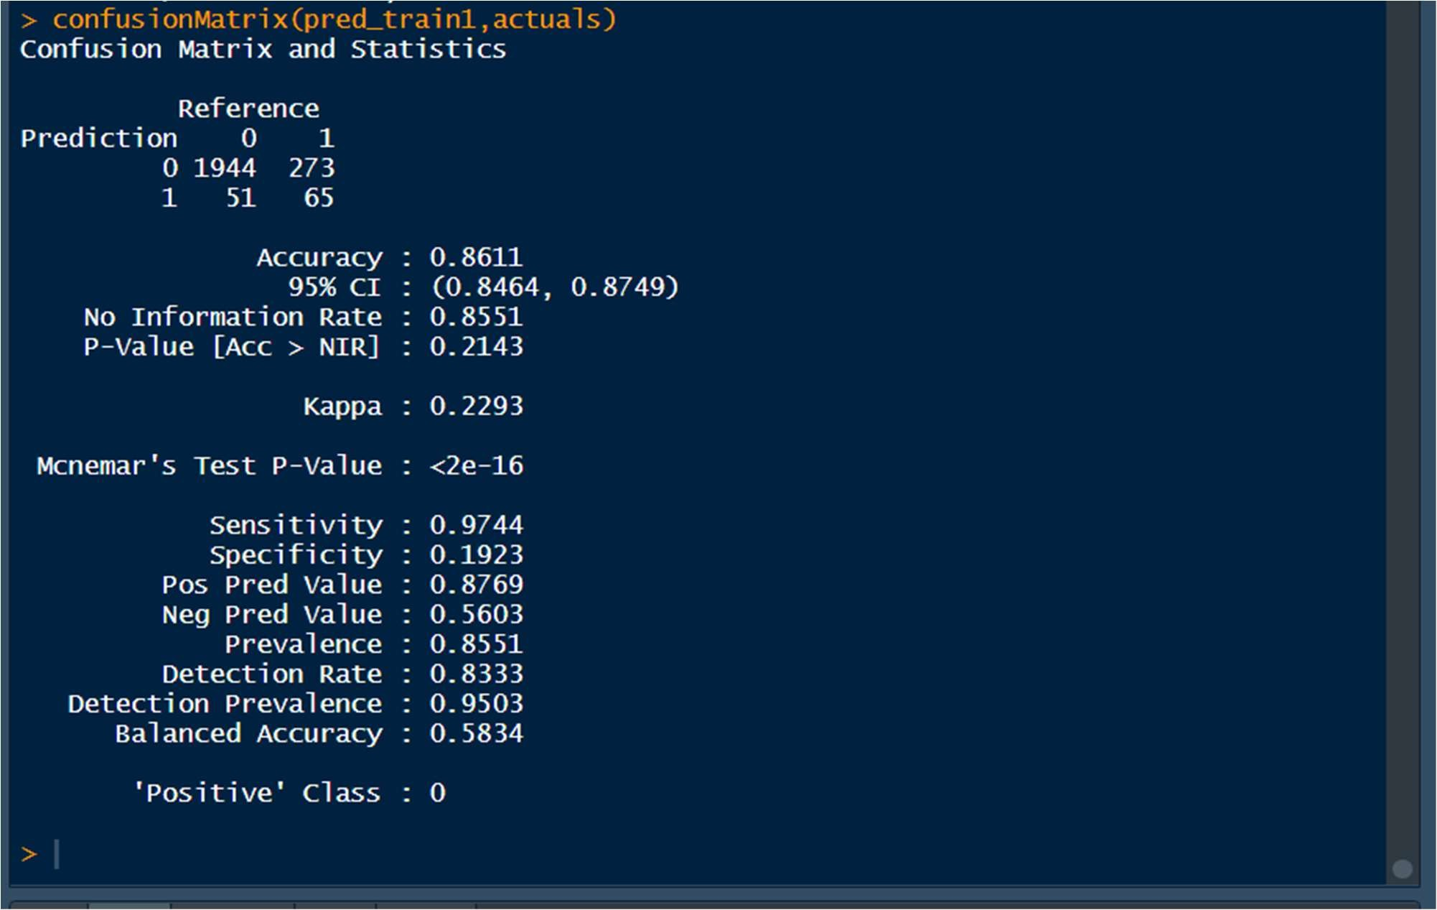

Accuracy : 0.8611

Sensitivity : 0.9744

Specificity : 0.1923

Baseline Accuracy

prop.table(table(cell.train$Churn))

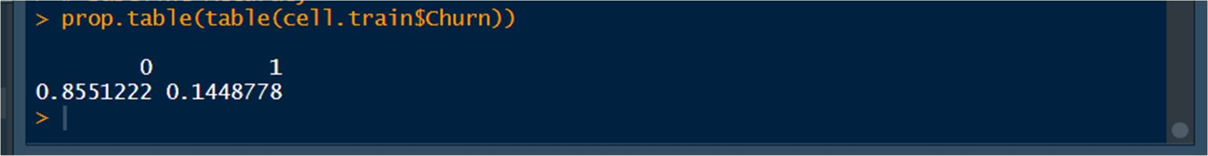

### 5.2 Interpretation Of Logistic Regression

Logistic Regression helps in estimating the parameters of a logistic model and it is statistical in nature. It is used to analyze the relationship between one dependent variable and one or more independent variables.

*We make an initial model including all the variables and study the model and call it ->train.lm1 train.lm1= glm(cell.train$Churn~., data = cell.train,family = binomial )

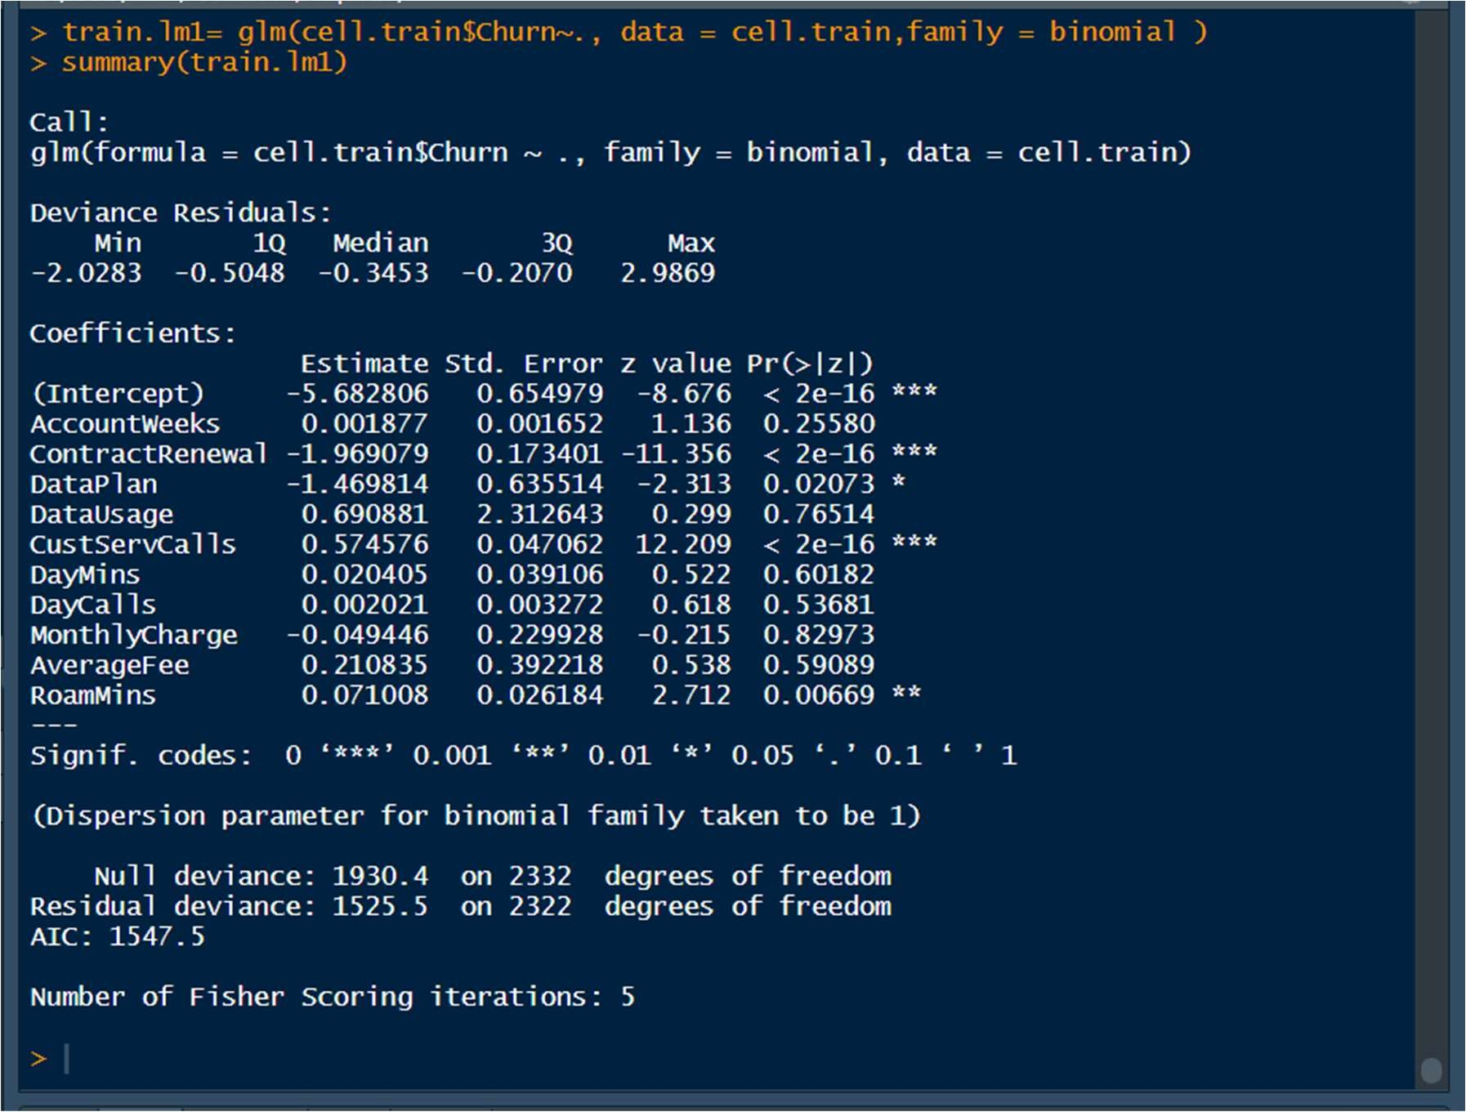

We see that AccountWeeks, ContractRenewal,DataPlan, CustServCalls and RoamMins are significant predictor of Churn.

* We will make another logistic regression model, this time without Data Usage and Monthly charge(these two are highly correlated variables) and call it ->train.lm2

train.lm2=glm(cell.train$Churn~AccountWeeks+ContractRenewal+DataPlan+CustServCalls+DayMins+DayCalls+AverageFee+ RoamMins, data = cell.train, family = binomial)

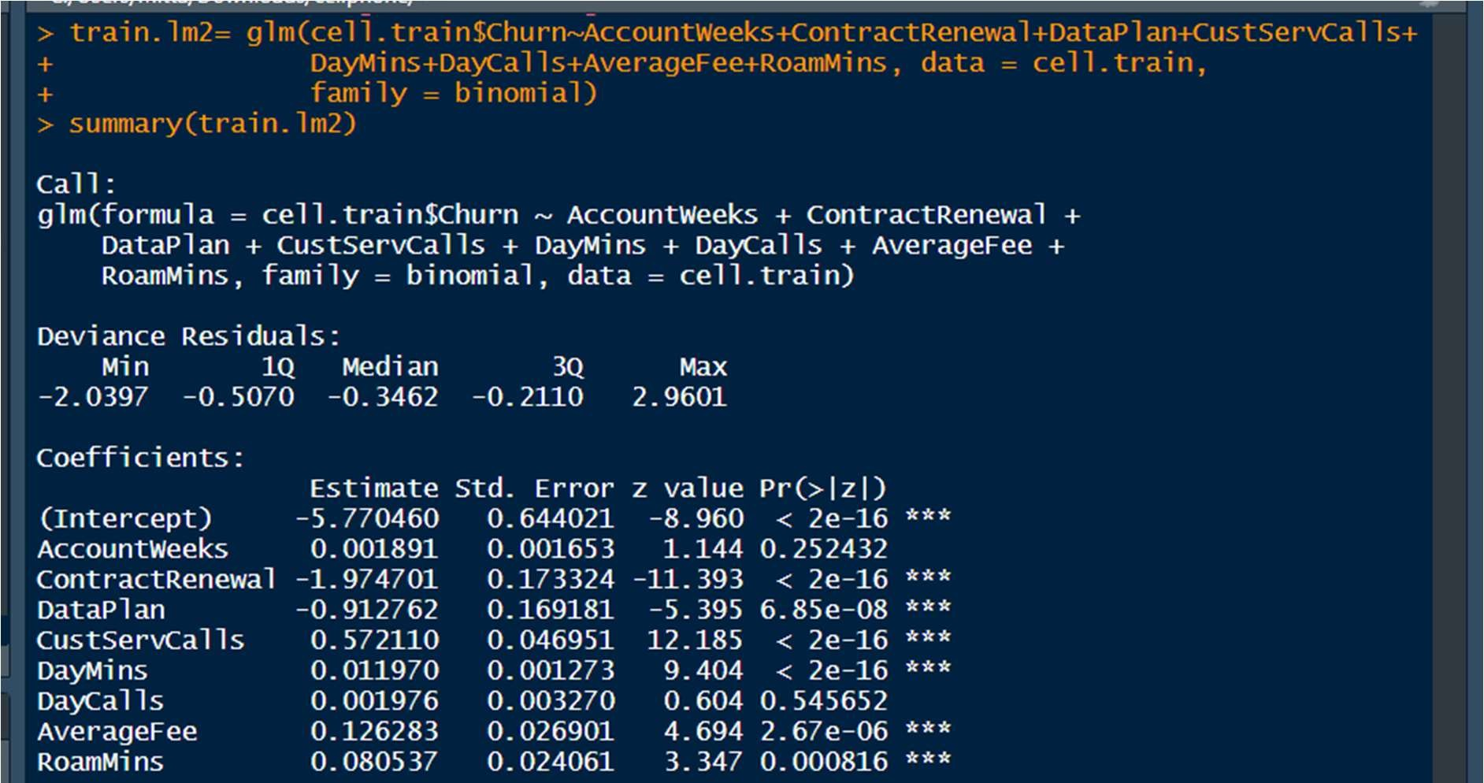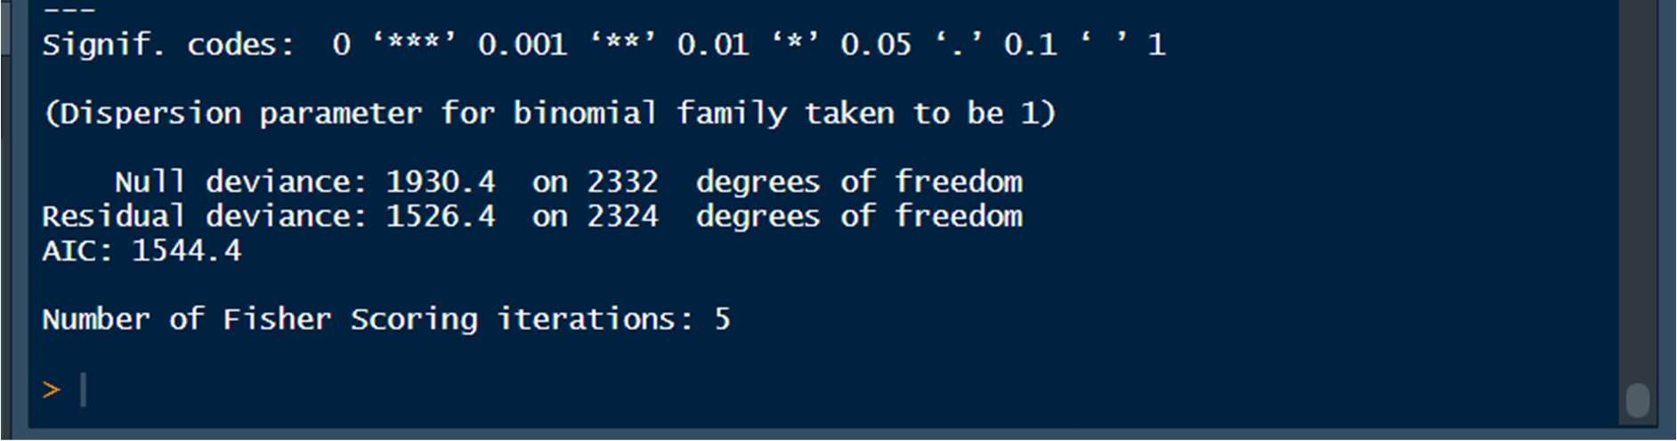

We see that ContractRenewal,DataPlan, CustServCalls, DayMins,AverageFee and RoamMins are significant predictors of Churn.

We see that except for AccountWeeks and DayCalls , everyother variable is significant. So, removing these 2 variables.Therefore, we create a final Regression model and call it -> train.lm.final

train.lm.final=glm(cell.train$Churn~ContractRenewal+DataUsage+CustServCalls+DayMins+AverageFee+RoamMins,data=cell. train,family = binomial())

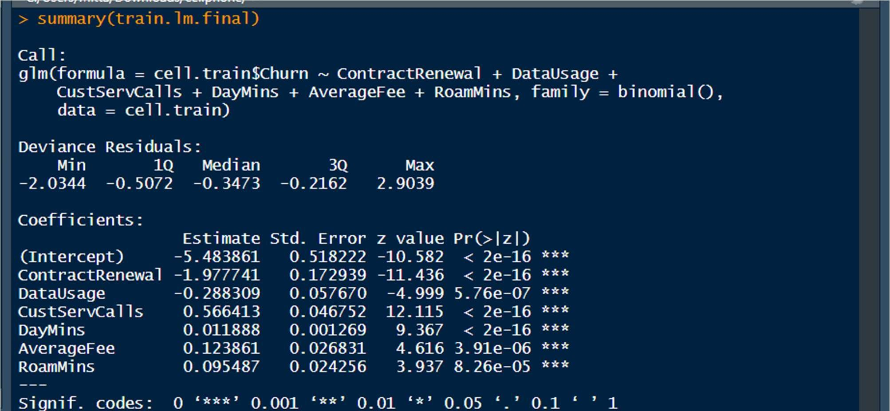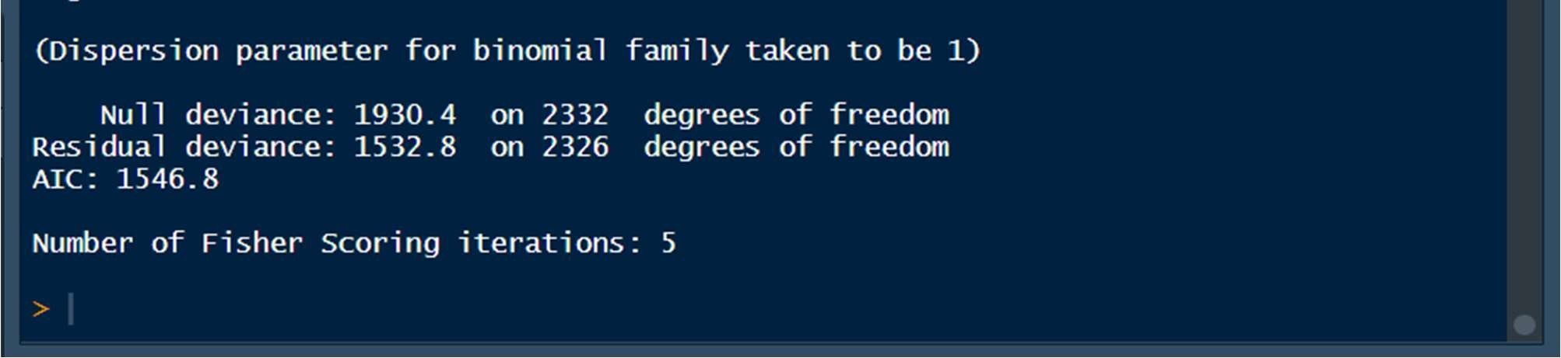

#### *Variance Inflation Factor for the Final model

vif(train.lm.final)

Now, for the final model, there is no high variance inflation for any variables.

Confusion Matrix Interpretation On The Test Data

confusionMatrix(pred_test,actuals)

Accuracy= 86.1%

Sensitivity : 0.9754

Specificity : 0.1862

#### 5.1.6 Predictions + Confusion Matrix on the Test Set

predict.test= predict(train.lm.final, type = "response", newdata = cell.test) predict.test

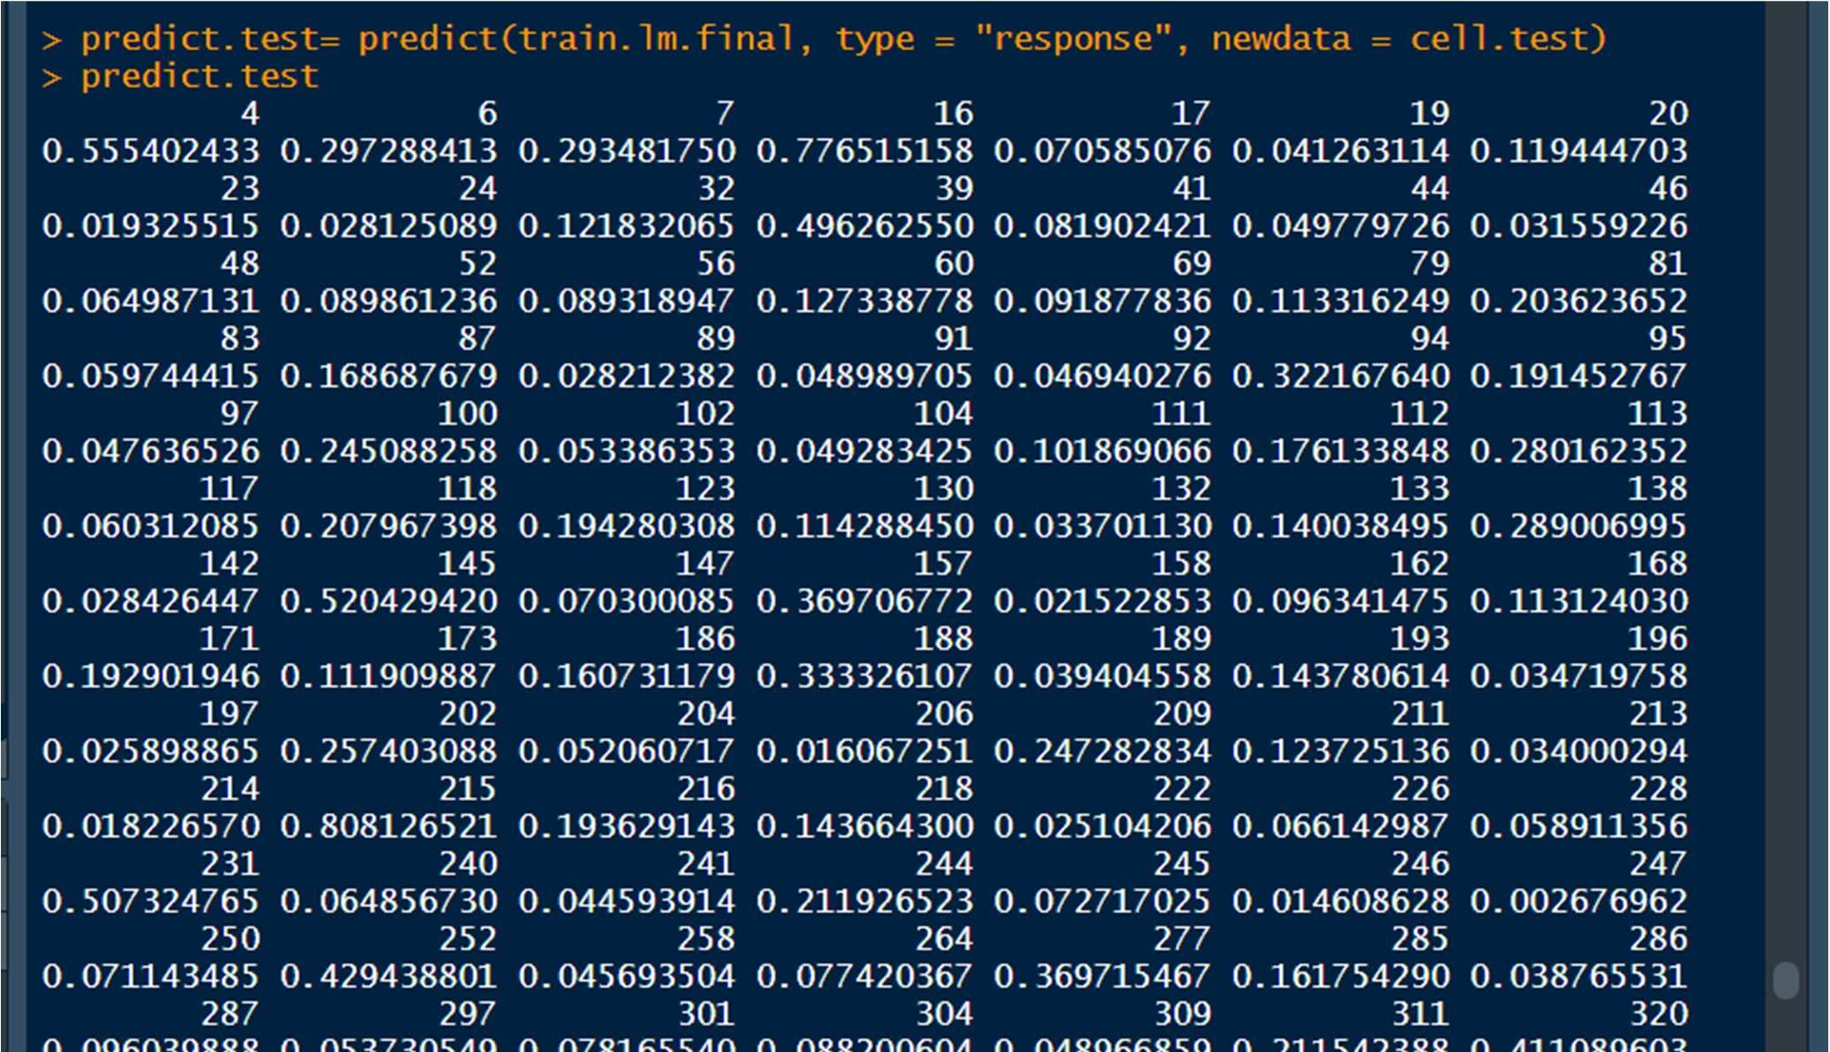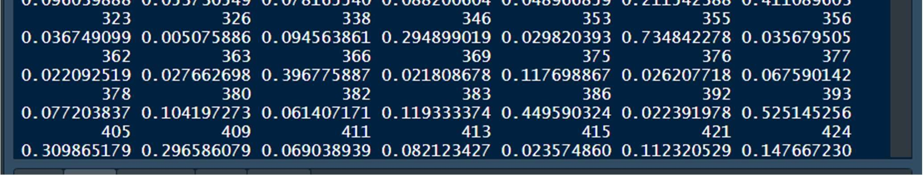

##### CONFUSION MATRIX FOR TEST DATA

pred_test<- ifelse(predict.test>0.5,1,0) str(pred_test) pred_test<- as.factor(pred_test) actuals<- as.factor(cell.test$Churn) str(actuals)

confusionMatrix(pred_test,actuals)

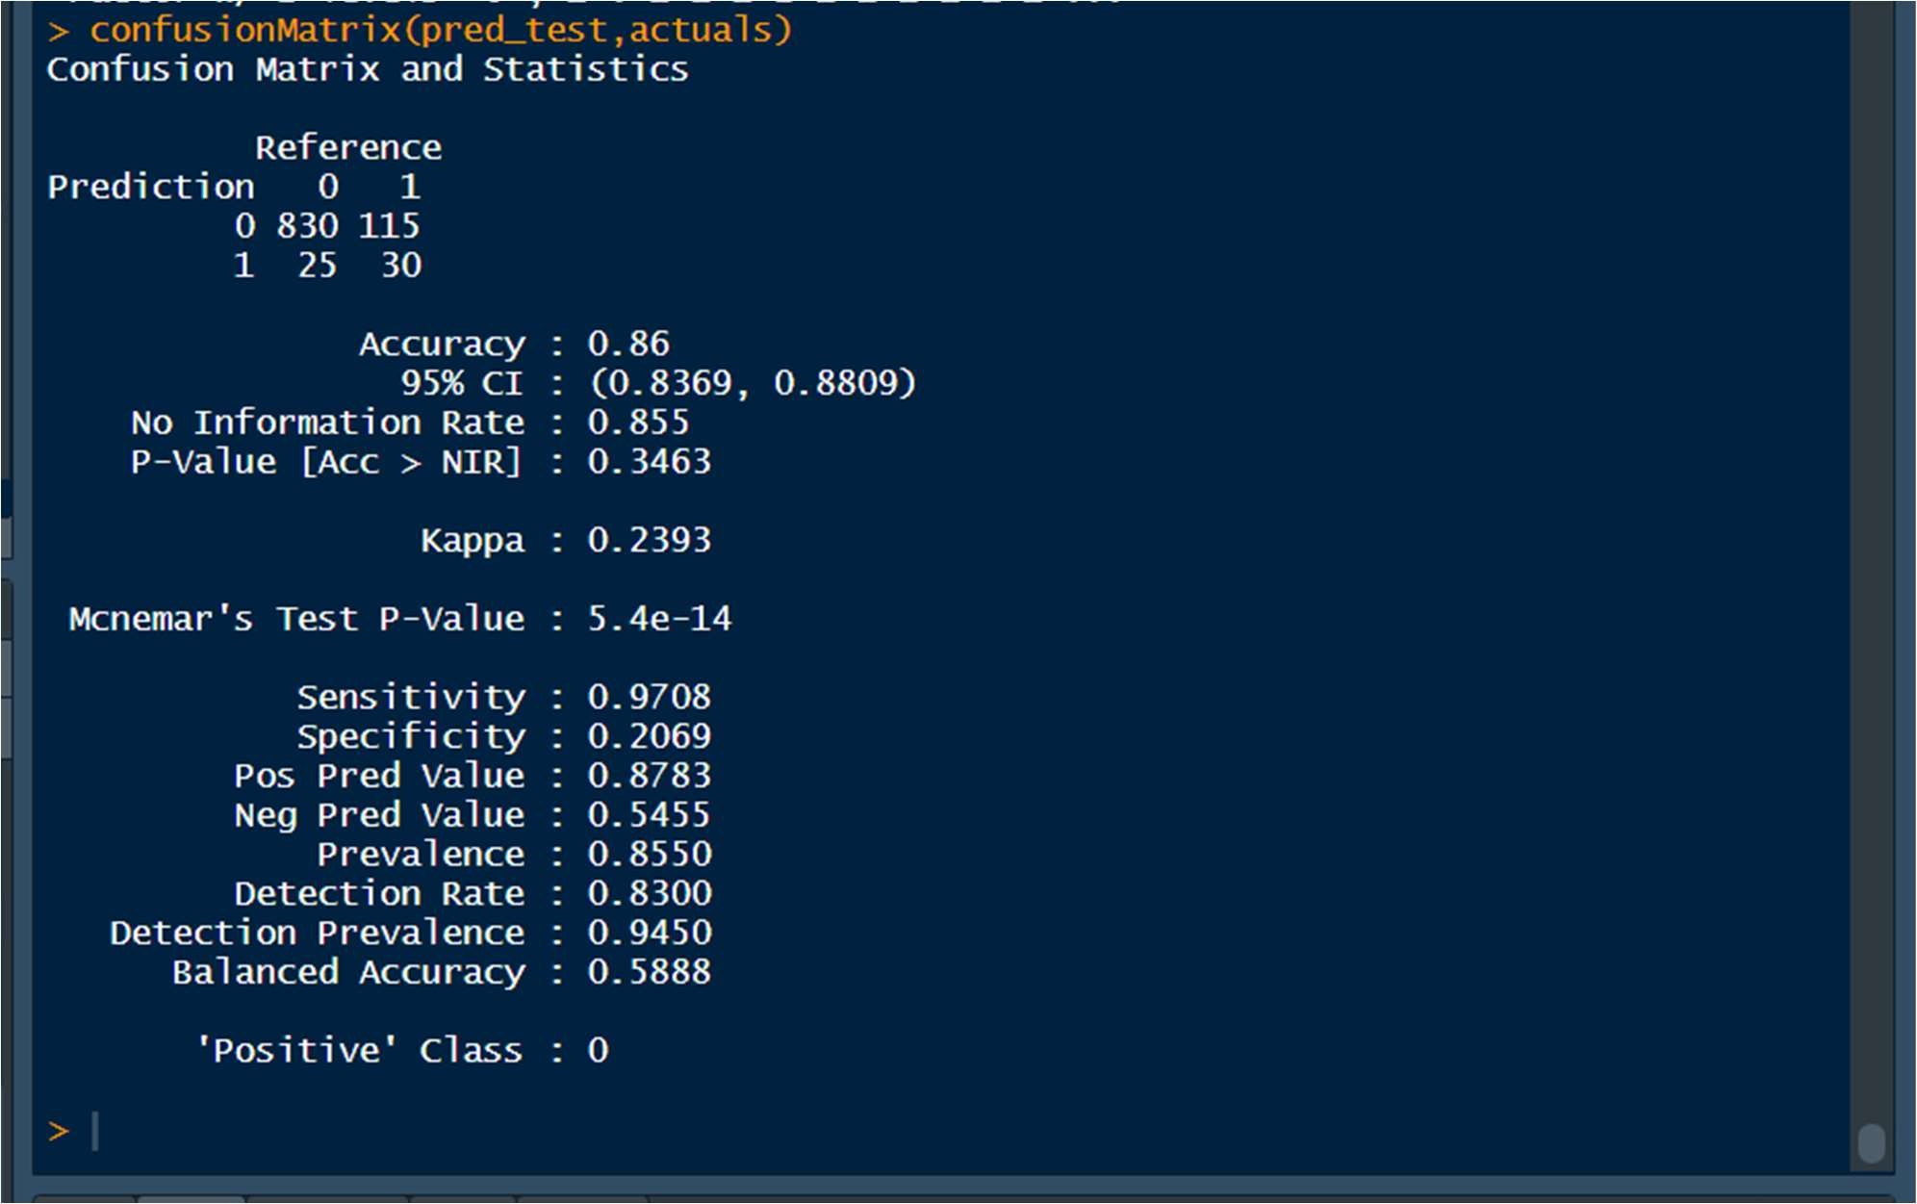

Accuracy= 86.1%

Sensitivity : 0.9754

Specificity : 0.1862

WE trade off sensitivity with specificity

## 6. OTHER MODEL PERFORMANCE MEASURES FOR LOGISTIC <KS, AUC, GINI>

### 6.1 Model Performance Measures On TRAINING DATA

#### 6.1.1 AUC using ROC curve

A good ROC curve is one that accomplishes both high Sensitivity and high specificity)

ROCRpred_train= prediction(predict.train, cell.train$Churn) perf_train= performance(ROCRpred_train,"tpr","fpr") plot(perf_train)

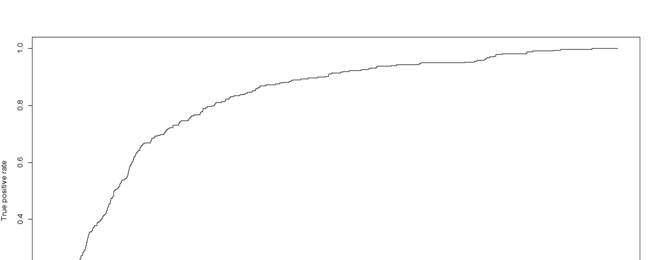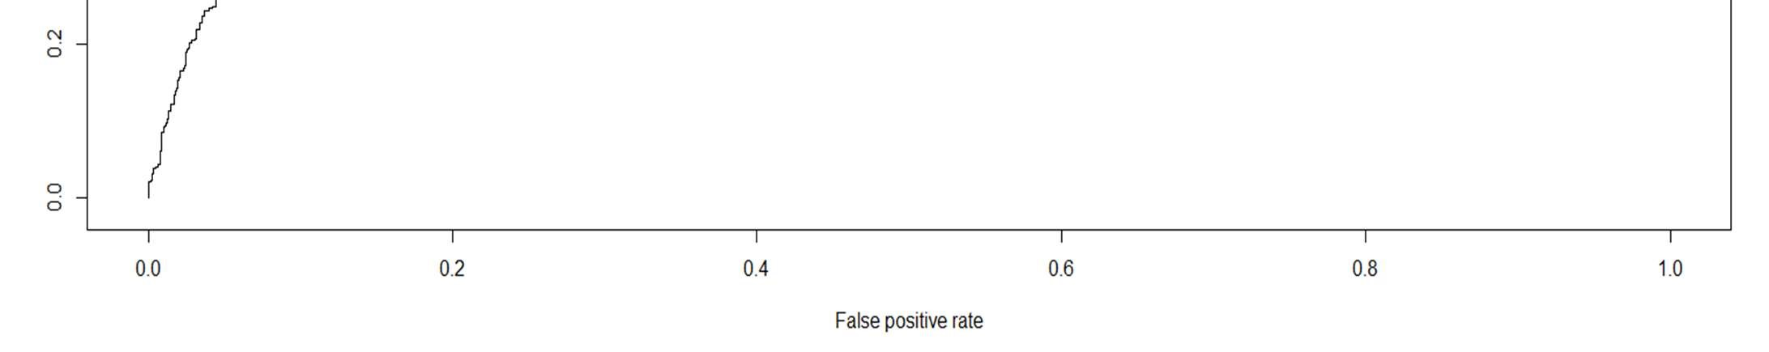

auc_train=performance(ROCRpred_train,"auc") as.numeric(auc_train@y.values)



Area under the curve is= 81.97%.

The ROC is kind of a counterpart for determining the quality of fit of the model.

If I take a churn and non-churn at random, there is an 81.97 percent chance that my model will indicate a higher risk of Churn than Non-Churn.

#### 6.1.2 KS Statistic for Training Data

The Kolmogorov Smirnov statistic is the max difference between the TP and the FP rate.

#H0: The predicted and the actual values belong to the same distribution.

#H1: The predicted and the actual values aren't alike/similar.

max(perf@y.values[[1]]-perf@x.values[[1]])

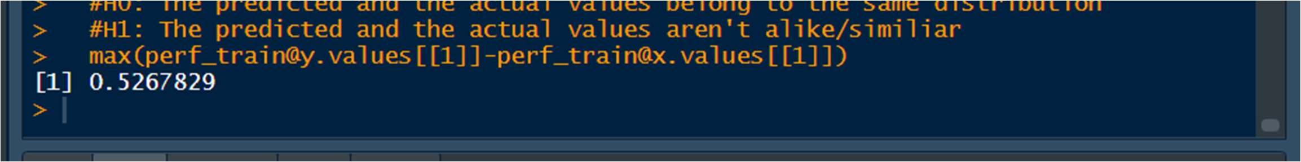

logis_KS_Train= max(perf_train@y.values[[1]]-perf_train@x.values[[1]])

The P-value is = .50110, which is greater than alpha of .05. We fail to reject the null hypothesis that and therefore, the predictions on the test set are quite similar to the actual test set itself.

#### 6.1.3 GINI for Training Data

A GINI coefficient measure the inequality among values of a frequency distribution.

A GINI of 0 means perfect equality, where all values are the same.

gini_train <- ineq(predict.train, "Gini")



#### **Concordance- Discordance

Concordance(actuals = cell.train$Churn,predictedScores = predict.train)

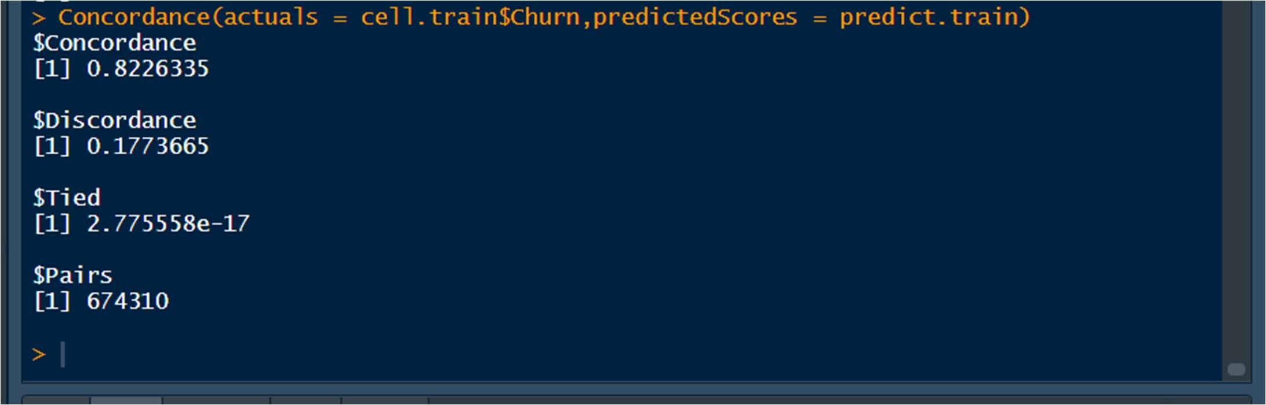

### 6.2 Model Performance Measures On TESTING DATA

#### 6.2.1 AUC by ROC curve

AUC is done by examining the ROC curve

(ROC shows the continuum of sensitivities and specificities)

train.lm.final$fitted.values plot(cell.train$Churn,train.lm.final$fitted.values)

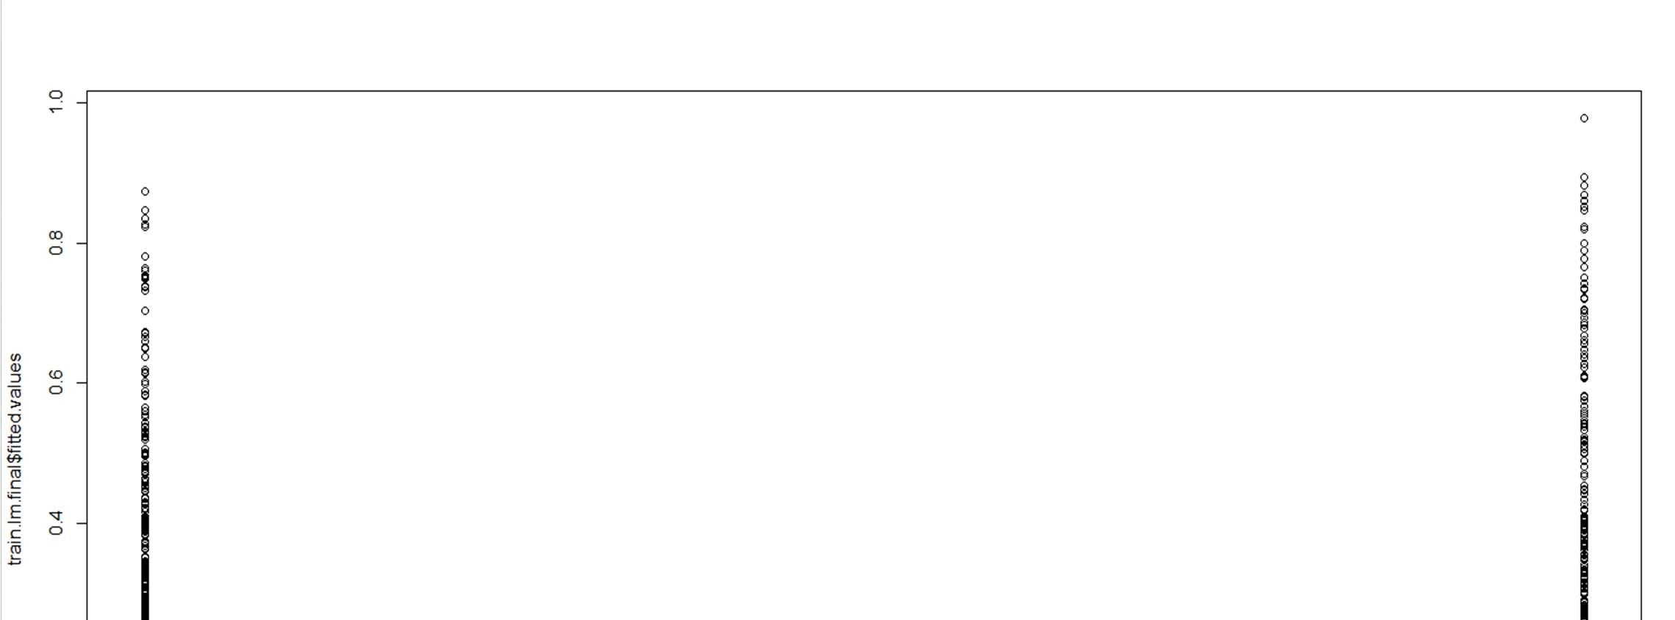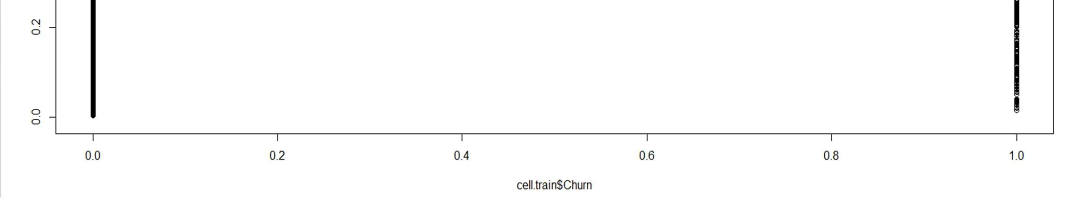

roc(cell.test$Churn,predict.test) plot(roc(cell.test$Churn,predict.test))

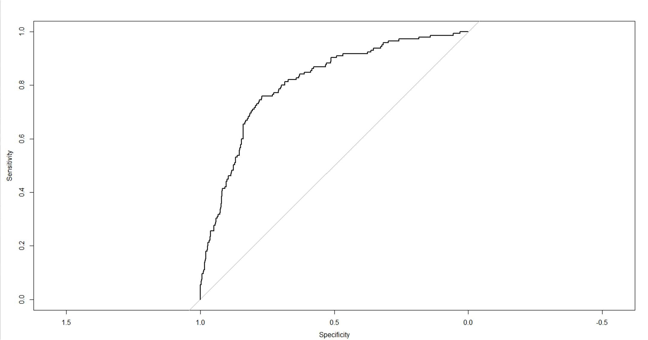

Area under ROC curve is 80.91%

# OR

ROCRpred_test= prediction(predict.test,cell.test$Churn) perf_test= performance(ROCRpred_test,"tpr","fpr")

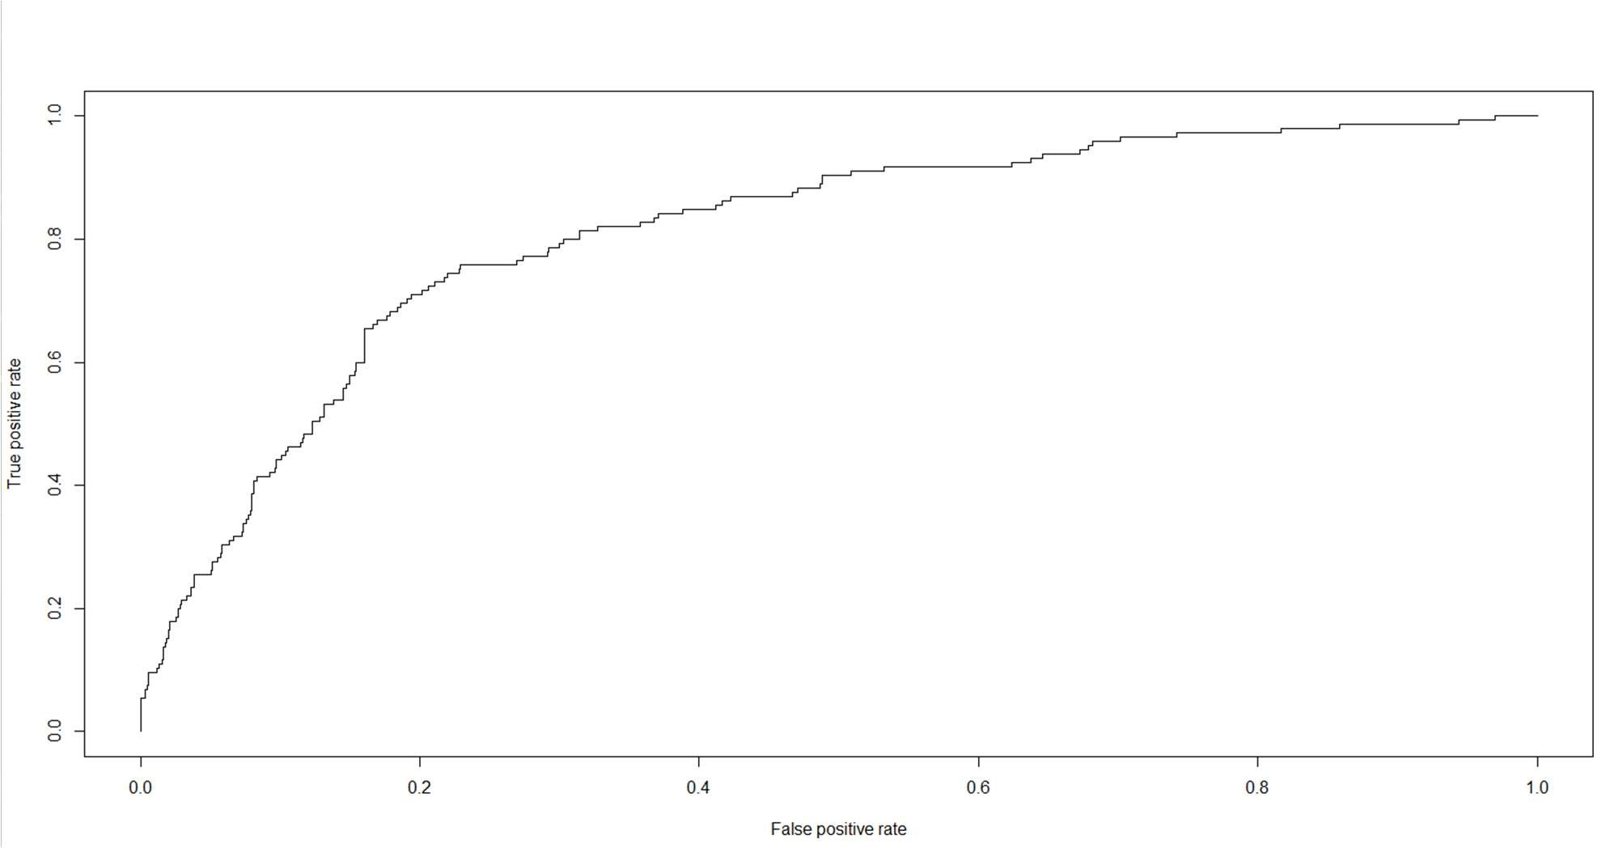

plot(perf_test) auc.perf_test=performance(ROCRpred_test,"auc") as.numeric(auc.perf_test@y.values)



Area under ROC curve is 80.91%

1.a good ROC curve is one that accomplishes both high Sensitivity and high specificity)

2.area under the curve is= 80.91%

The ROC is sort of a counterpart for determining the quality of fit of the model.

3.If I take a churn and non-churn at random, there is an 80.90 percent chance that my model will indicicate a higher risk of Churn than Non-Churn.

#### 6.2.2 KS Statistic

The Kolmogorov Smirnov statistic is the max difference between the TP and the FP rate.

#H0: The predicted and the actual values belong to the same distribution

#H1: The predicted and the actual values aren't alike/similiar

max(perf_test@y.values[[1]]-perf_test@x.values[[1]])



logis_KS_test= max(perf_test@y.values[[1]]-perf_test@x.values[[1]])

The P-value is = 0.5272434, which is greater than alpha of .05.

We fail to reject the null hypothesis that and therefore, the predictions on the test set are quite similar to the actual test set itself.

#### 6.2.3 GINI for Test Data

A GINI coefficient meansure the inequality among values of a frequency distribution.

A gini of 0 means perfect equality, where all values are the same.

ineq(predict.test, "Gini")

gini_test <- ineq(predict.test, "Gini")

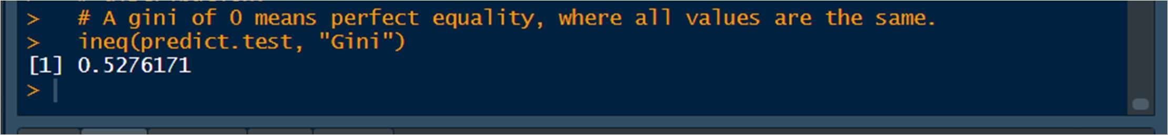

Gini Value is = .5542

Therefore, in this case, GINI might not be the best measure to check for logistic regression.

#### **Concordance- Discordance

Concordance(actuals = cell.test$Churn,predictedScores = predict.test)

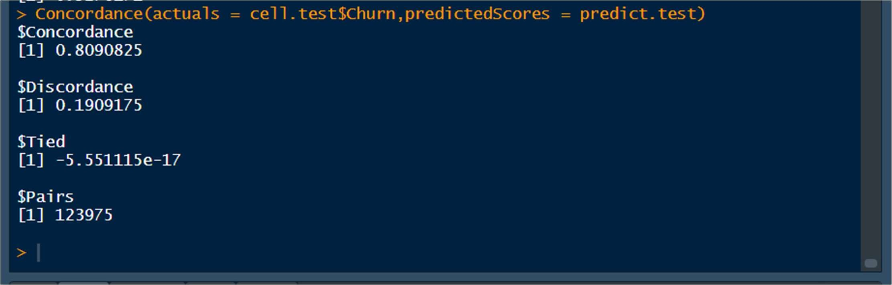

6.2 Interpretation Of Model Performance Measures For Logistic

## a) KS

We use hypothesis testing in this.

#H0: The predicted and the actual values belong to the same distribution.

#H1: The predicted and the actual values aren't alike/similar.

max(perf_test@y.values[[1]]-perf_test@x.values[[1]])



The P-value is = 0.5293, which is greater than alpha of .05.

we fail to reject the null hypothesis that and therefore, the predictions on the test set are quite similar to the actual test set itself.

### b) AUC by ROC Curve

The Kolmogorov Smirnov statistic is the max difference between the TP and the FP rate.

plot(roc(cell.test$Churn,predict.test))

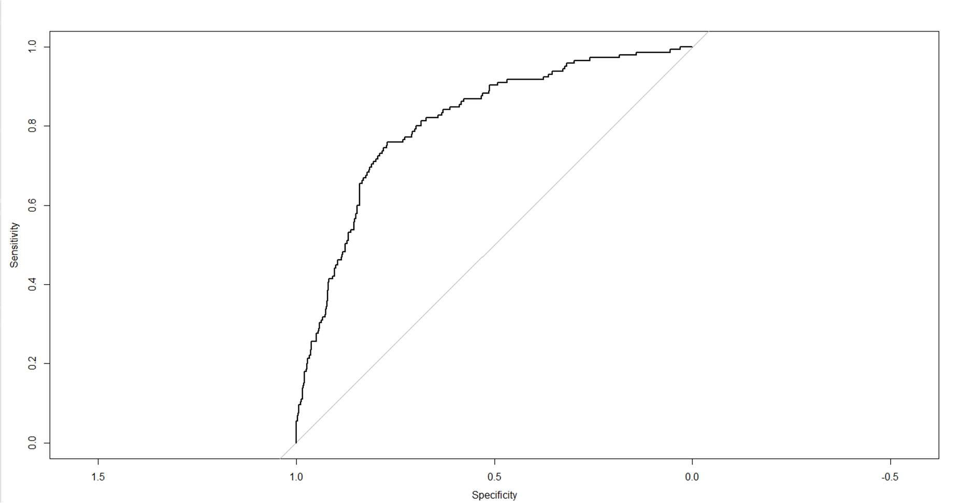

Area under ROC curve is 80.91%

### c) GINI

A GINI coefficient meansure the inequality among values of a frequency distribution.

A gini of 0 means perfect equality, where all values are the same.

ineq(predict.test, "Gini")

Gini Value is = .5276

Therefore, in this case, GINI might not be the best measure to check for logistic regression.

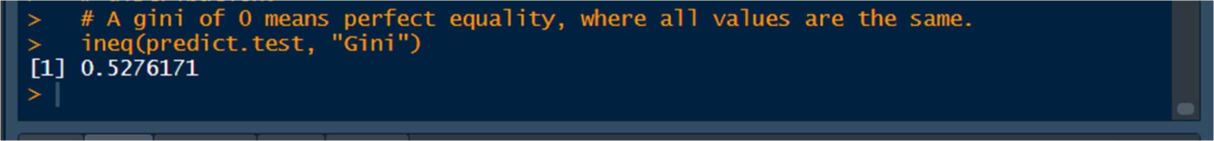

**** Amongst these 3 models , AUC by ROC curve gives us a better idea about the model’s interpretation

## 7.KNN MODEL

### 7.1 Applying KNN Model

#### For k=13

knn.prediction= knn(cell.train[-1],cell.test[-1],cell.train[,1],k=13)

knn.prediction

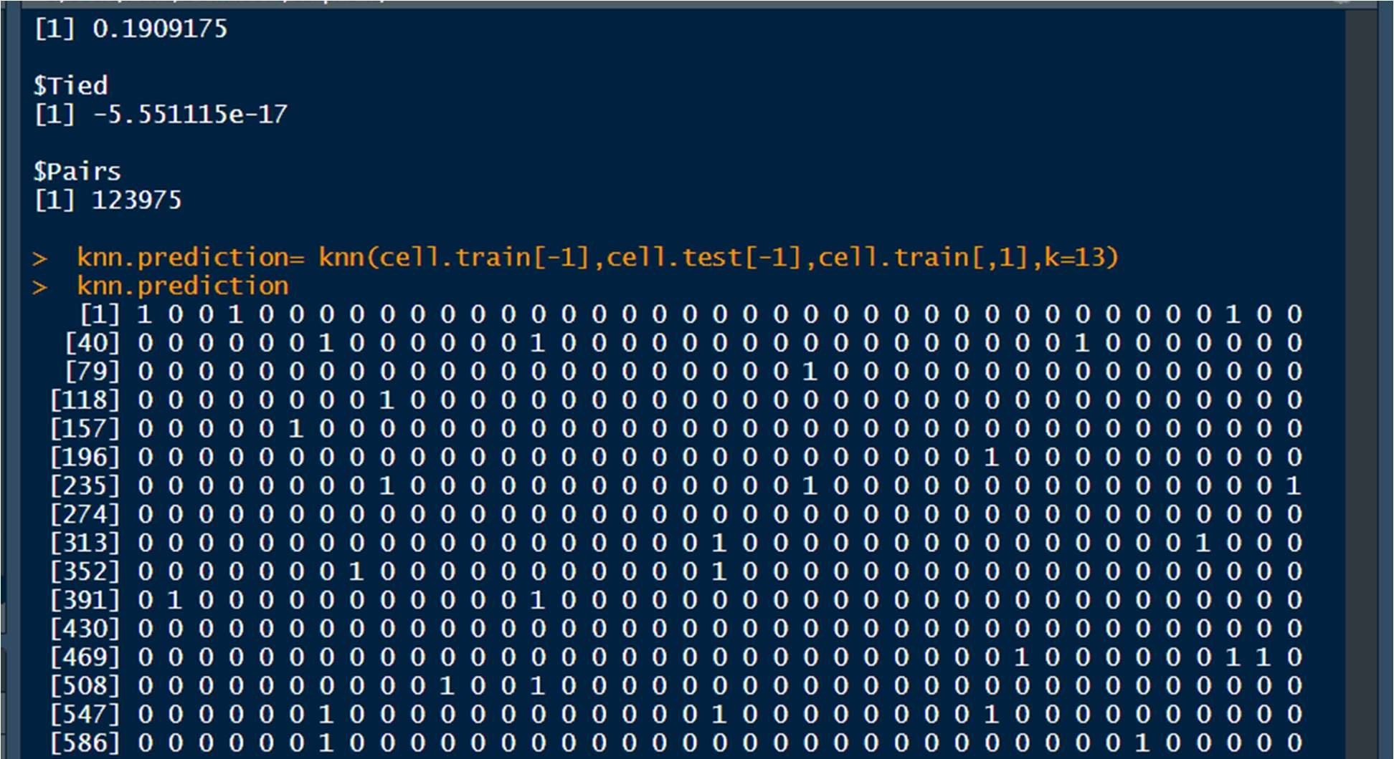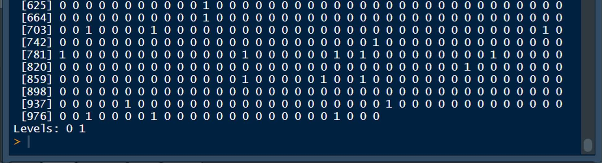

knn.prediction= as.factor(knn.prediction) cell.test$Churn= as.factor(cell.test$Churn) cell.train$Churn= as.factor(cell.train$Churn)

#### Confusion matrix for Test set when k=13

confusionMatrix(knn.prediction,cell.test$Churn)

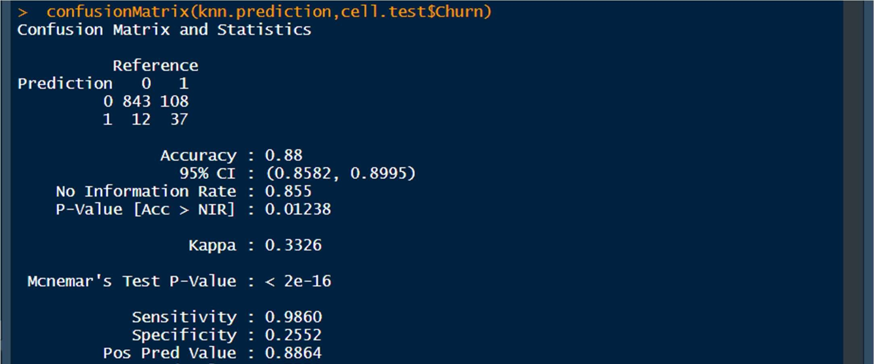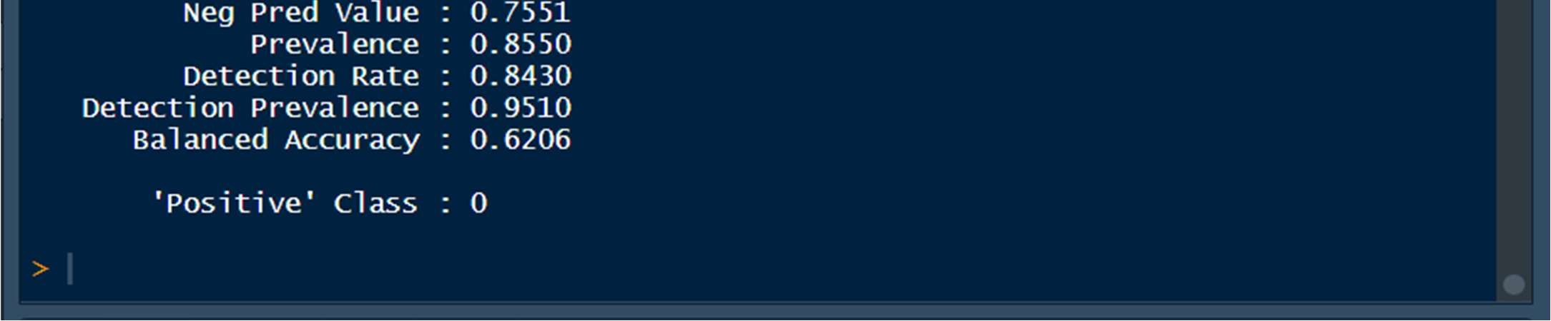

Accuracy =0.88

Sensitivity : 0.9860

Specificity : 0.2552

#### For k=7

knn.prediction= knn(cell.train[-1],cell.test[-1],cell.train[,1],k=7) knn.prediction

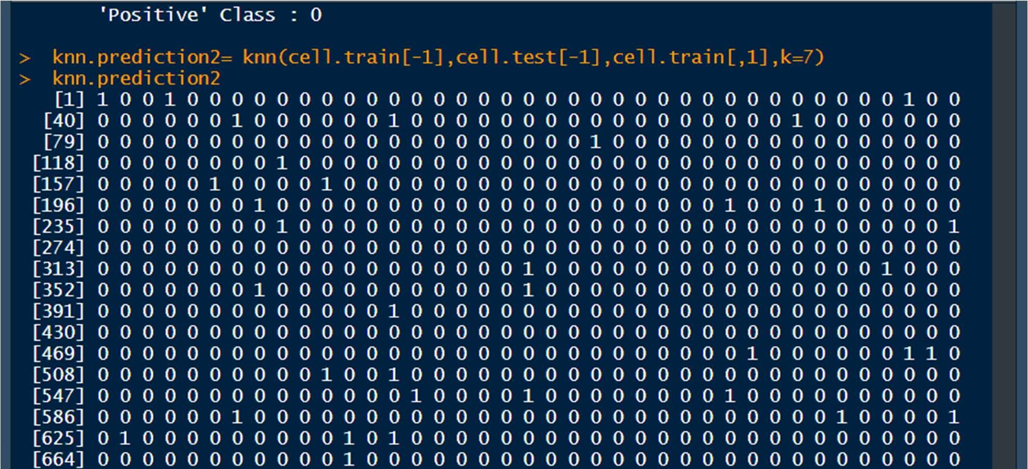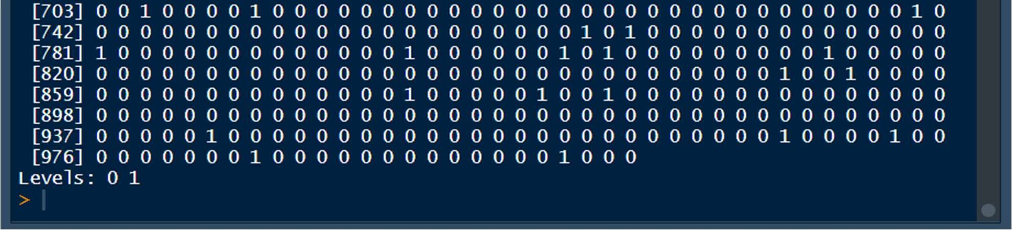

knn.prediction= as.factor(knn.prediction) cell.test$Churn= as.factor(cell.test$Churn) cell.train$Churn= as.factor(cell.train$Churn)

### Confusion matrix for Test set when k=7

confusionMatrix(knn.prediction,cell.test$Churn)

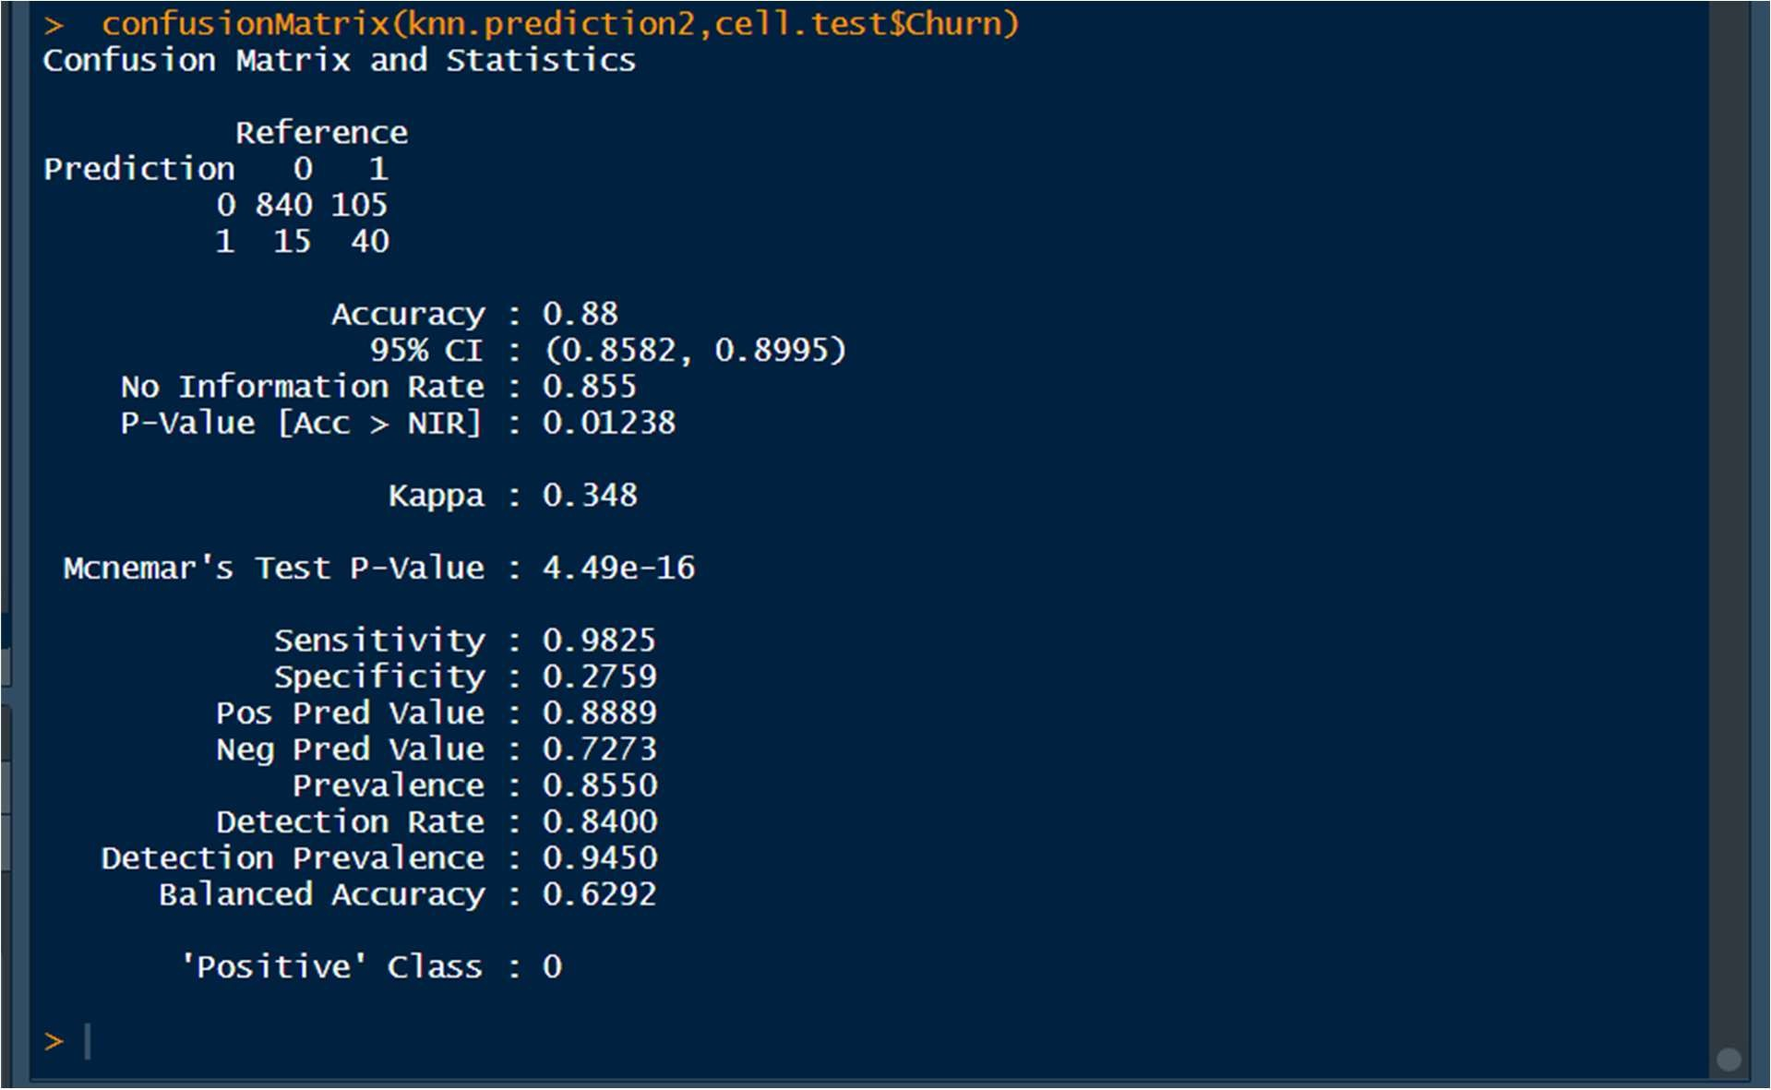

Accuracy : 0.88

Sensitivity : 0.9825

Specificity : 0.2759

### 7.2 Interpretation Of KNN Model

KNN supports non-linear solutions and can output only the labels.

The KNN predictions are calculated by simultaneously creating a KNN model and come out to be 0 or 1 depending on churn and no-churn.

The Accuracy comes out to be= 88%

Reference

Prediction 0 1

1. 843 108
2. 12 37

Sensitivity : 0.9860

Specificity : 0.2552

## 8. NAÏVE BAYES MODEL

### 8.1 Applying Naive Bayes Model

It calculates the conditional probabilites of a categorical class variable given the independent predictor variables using the Bayes rule.

cell.train$Churn<- as.factor(cell.train$Churn)

NB.model=naiveBayes(cell.train$Churn~.,data=cell.train) (NB.model)

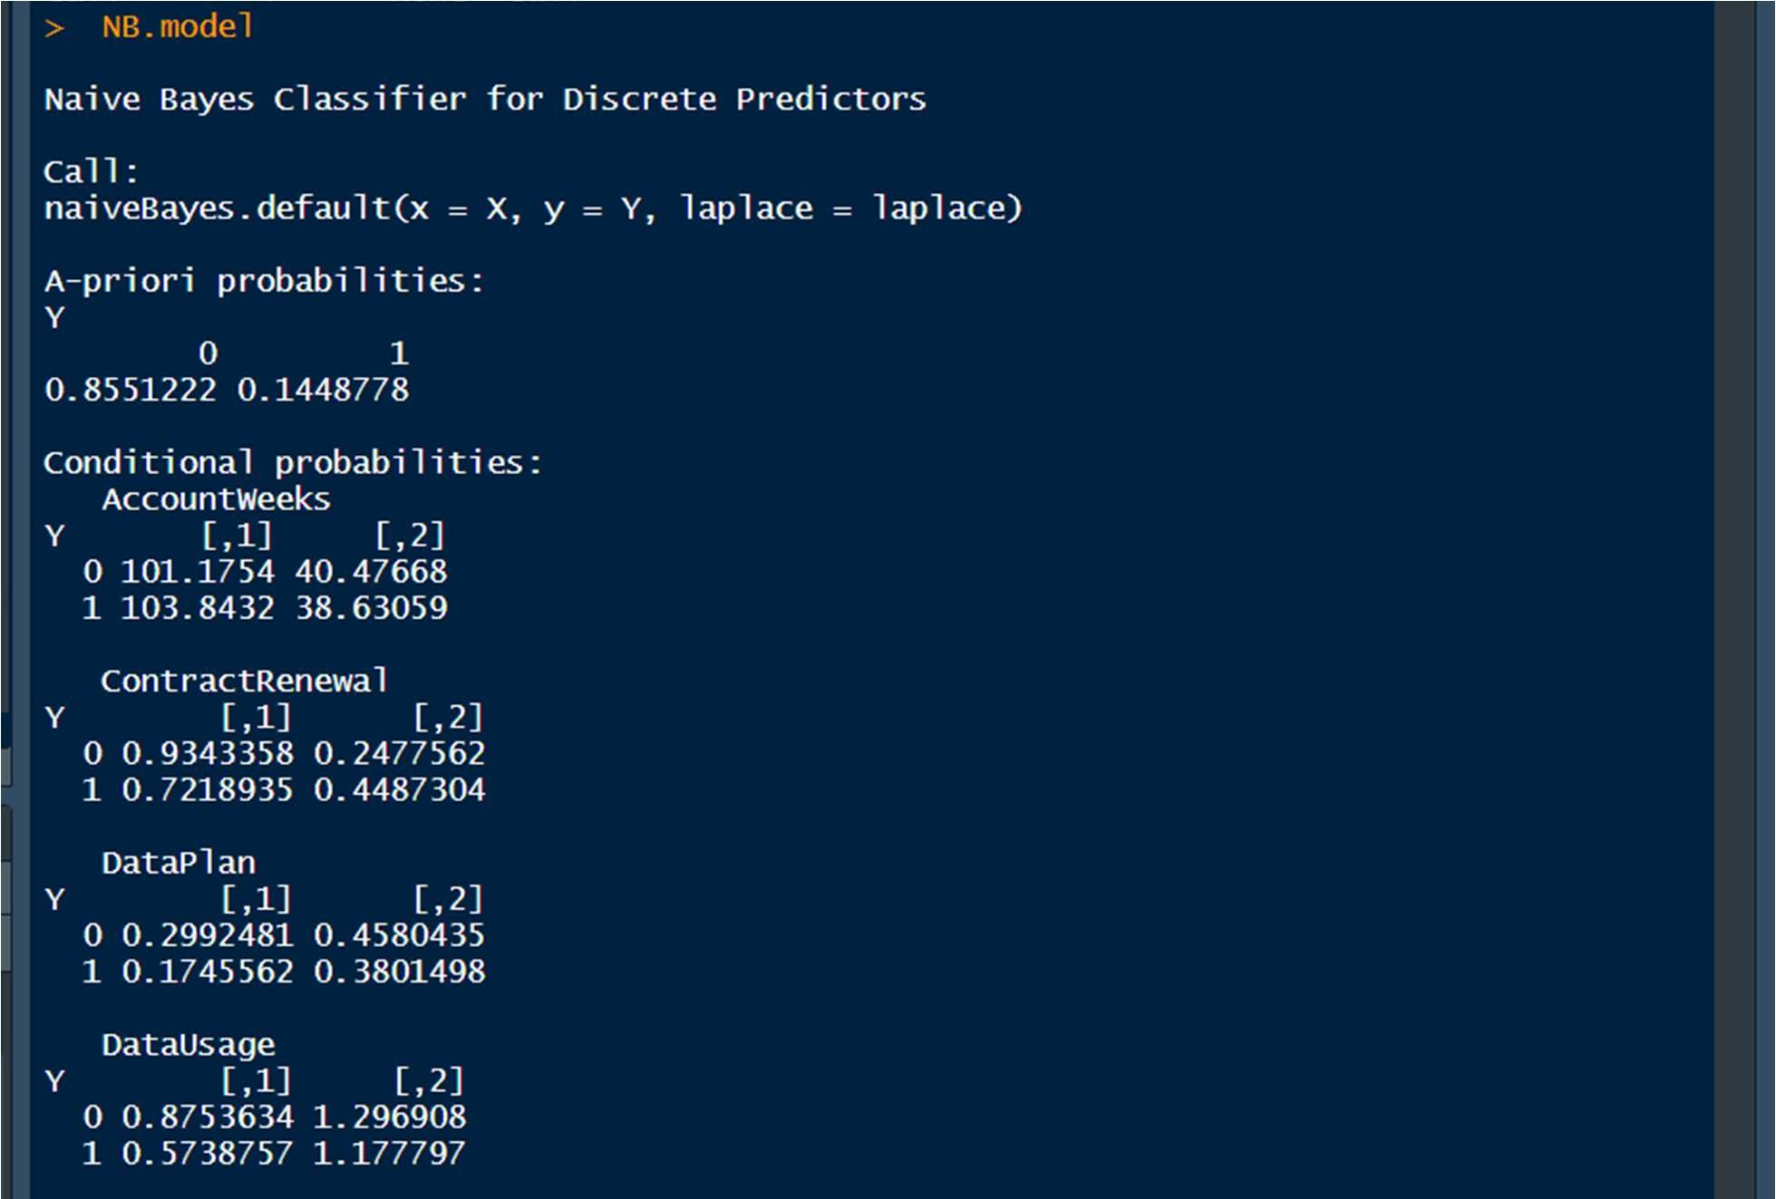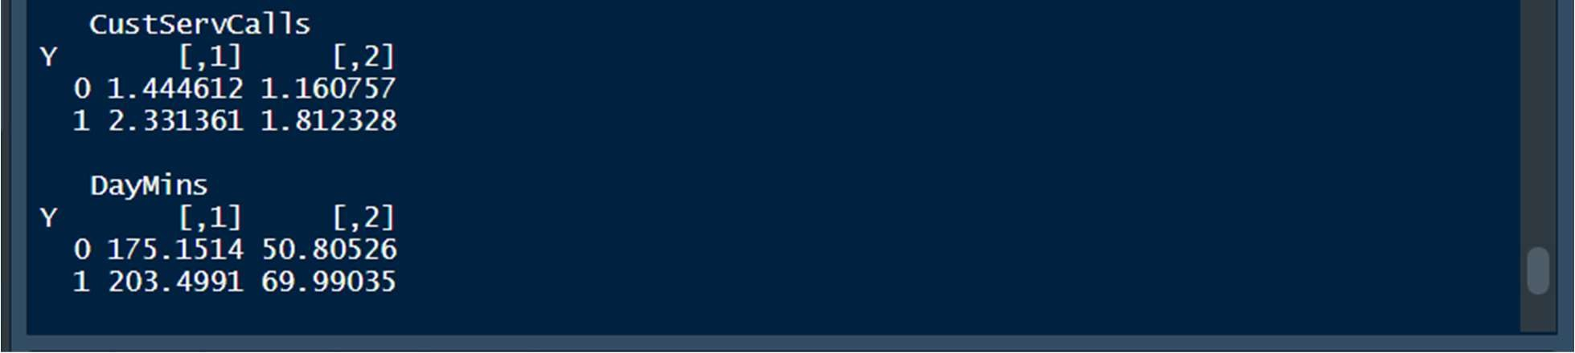

Let's consider Contract renewal:

The average Contract renewal given no-churn is 0.931 and The standard deviation given no churn is 0.2521

#### **For Train data

## Predicting values on Train Data

cell.train$Churn<- as.factor(cell.train$Churn)

NB.predictions_train= predict(NB.model, newdata= cell.train)

#### Confusion matrix of Train Dataset

caret::confusionMatrix(NB.predictions_train,cell.train$Churn )

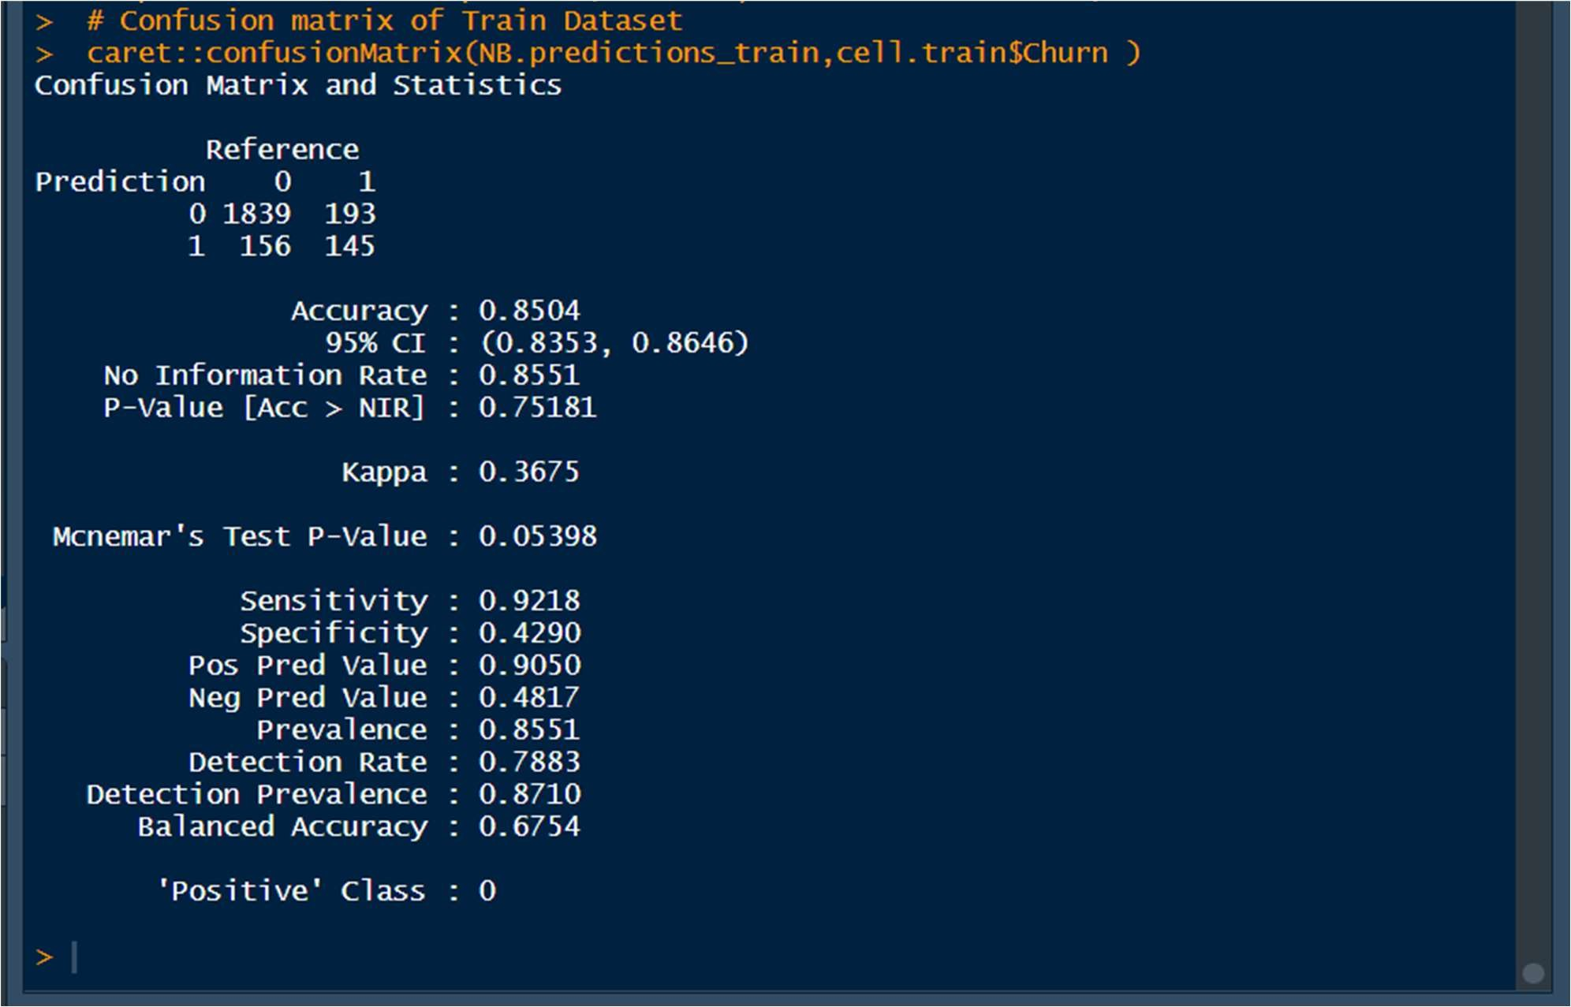

# Accuracy : 0.853

# Sensitivity : 0.9253

# Specificity : 0.4260

#### **For Test Data

##### ## Predicting values on Test

cell.test$Churn<- as.factor(cell.test$Churn)

NB.predictions_test= predict(NB.model, newdata= cell.test)

NB.predictions_test= as.factor(NB.predictions_test)

#### Confusion matrix of Test Dataset

caret::confusionMatrix(NB.predictions_test,cell.test$Churn )

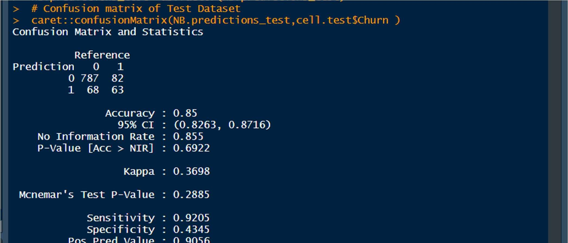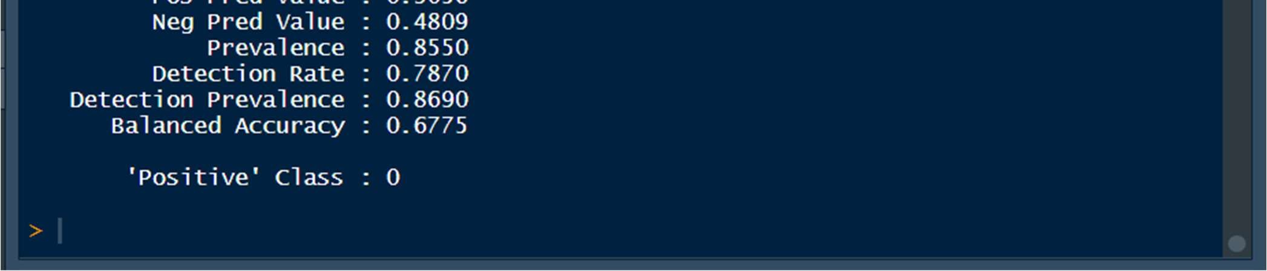

Accuracy : 0.861

Sensitivity : 0.9392

Specificity : 0.4000

### 8.2 Interpret Naive Bayes Model

In Naïve Bayes, we can take each feature separately and determine it statistically giving certain conditions.

ContractRenewal

Y [,1] [,2]

1. 0.9343358 0.2477562
2. 0.7218935 0.4487304

Let's consider Contract renewal:

The average Contract renewal given no-churn is 0.934 and the standard deviation given no-churn is 0.2477

The Accuracy is= 85.04%

Reference

Prediction 0 1

* 1. 1839 193
  2. 156 145

Sensitivity : 1839/(1839+156)=0.9253

Specificity : 193/(193+145)=0.4260

## 9. CONFUSION MATRIX INTERPRETATION FOR ALL MODELS

### 9.1 For Logistic regression- Testing Data

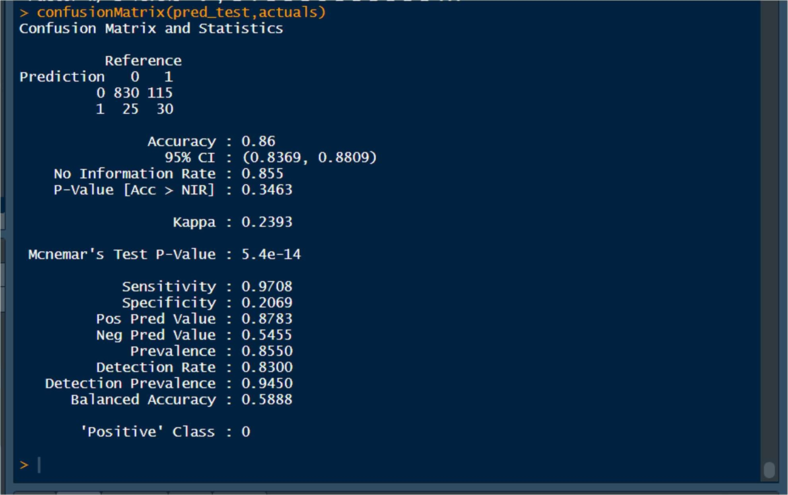

Accuracy= 86.1%

Sensitivity : 0.9754

Specificity : 0.1862

9.2 For KNN:

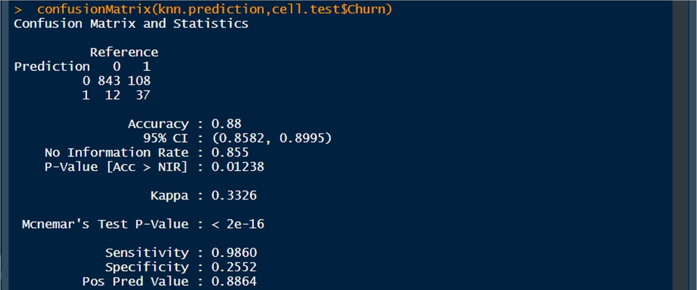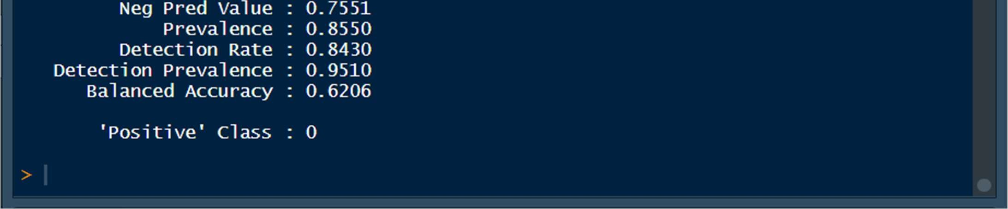

Accuracy =88%

Sensitivity : 0.9860

Specificity : 0.2552

9.3 For Naïve Bayes:

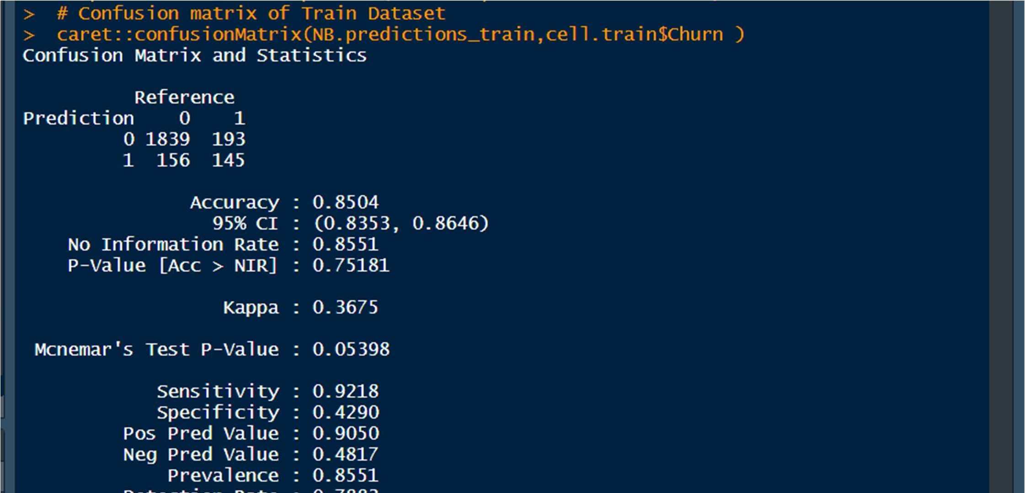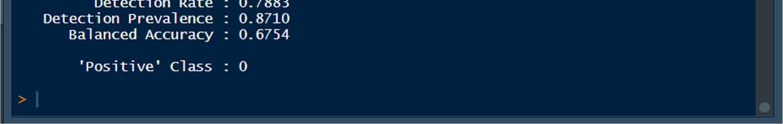

Accuracy : 0.853

Sensitivity : 0.9253

Specificity : 0.4260

WE Observe that the ACCURACY given by KNN MODEL is the Largest amongst the Logical Regression, Naïve Bayes and KNN Model.

But still we’ll choose Logistic regression model because we can interpret it in various ways using many different statistics.

RCODE:

setwd("C:/Users/mitta/Downloads/cellphone") getwd()

install.packages("readr") install.packages("dplyr") install.packages("ggplot2") install.packages("GGally") install.packages("caTools") install.packages("rms") install.packages("ROCR") install.packages("pROC") install.packages("Hmisc") install.packages("stringi") install.packages("e1071") install.packages("class") ininstall.packages("blorr") install.packages("ineq") install.packages("caret") install.packages("InformationValue")

library(ggplot2)

library(readr) library(dplyr) library(GGally) library(caTools) library(rms) library(ROCR) library(pROC) library(Hmisc) library(e1071) library(class) library(readxl) library(blorr) library(InformationValue) library(caret) library(ineq)

1.1

cellphone= read.csv("Cellphone.csv") str(cellphone) attach(cellphone) colnames(cellphone)[1]<- 'Churn' str(cellphone) summary(cellphone) describe(cellphone)

#UNIVARIATE ANALYISIS

#done for both categorical and continuous variables #must be numeric for histogram plotting

#HISTOGRAM

hist(DataUsage) hist(AverageFee) hist(MonthlyCharge) hist(RoamMins) hist(DayMins)

#average fee , Roam Mins are normally distributed

#Using Boxplot now boxplot(cellphone)

# There are outliers in - Accountweeks, DayMins, DayCalls, MonthlyCharge, AverageFee,RoamMins

#BIVARIATE ANALYSIS plot(DayMins,DayCalls)

qplot(DataPlan,fill=DataUsage,data=cellphone, geom="bar", main = "Dataplan Vs Data Usage", xlab = "Data Plan", ylab = "Data Usage")

plot(DataUsage,MonthlyCharge) plot(DataUsage,AverageFee) plot(RoamMins,MonthlyCharge) #---------------------------------------------------------------------------------------- 1.2

# OUTLIER DETECTION

#- USING BOXPLOTS

boxplot(cellphone)

# There are outliers in - Accountweeks, DayMins, DayCalls, MonthlyCharge, AverageFee,RoamMins

#MISSING VALUE DETECTION null= is.na(cellphone) summary(null) #OR

colSums(is.na(cellphone))

#there are no missing values in our dataset

summary(cellphone) dim(cellphone) head(cellphone,10) tail(cellphone,10)

#---------------------------------------------------------------------------------------- 1.3

ggcorr(cellphone,label=TRUE)

#There is multicollenearity between 5 variables- Data Plan, Monthly Usage, Monthly Charge,

#Data Usage, Data mins

#Multicollinearity occurs when two or more predictors in a regression equation are correlated.

#We should not treat multicollinearity because right now logistic regression does not

#get affected by it. Although we could perform PCFA in order to reduce the variables and #group the similar and highly correlated variables together to forma single variable.

#---------------------------------------------------------------------------------------- str(cellphone) colnames(cellphone)

1.4

#The data consists of all numeric and integer variables.

#There is the issue of multicollinearity amongst the variable

#There are outliers in certain variable rows

#There are no missing values in the data set

#The predictor variables/independent variables are:

# "AccountWeeks" "ContractRenewal" "DataPlan" "DataUsage"

# "CustServCalls" "DayMins" "DayCalls"

#"MonthlyCharge" "AverageFee" "RoamMins"

#The Dependent variable is : Churn

#--------------------------------------------------------------------------------

# 2.1 APPLYING LOGISTIC REGRESSION

set.seed(1)

split = sample.split(cellphone$Churn, SplitRatio = .70)

cell.train= subset(cellphone, split== TRUE) cell.test= subset(cellphone,split== FALSE)

dim(cell.train) dim(cell.test)

prop.table(table(cellphone$Churn))

#LOGISTIC REGRESSION MODEL

train.lm1= glm(cell.train$Churn~., data = cell.train,family = binomial ) summary(train.lm1)

# Multicollinearity Check

vif(train.lm1)

#This shows that the vraiables have multicollinearity problem.

#DataPlan , DAtaUsage, DayMins, MonthlyCharge, and AverageFee are the correlated variables.

# The Relationship netween the variables has lead to a an inflation in their variances #which means an instability in the coefficient itself.

# Here,

#1.We see that AccountWeeks, ContractRenewal,DataPlan, CustServCalls and RoamMins # are significant predictor of Churn.

# 2.We will make another logistic regression model, this time without Data Usage # Monthly charge(these two are highly correlated variables)

train.lm2= glm(cell.train$Churn~AccountWeeks+ContractRenewal+DataPlan+CustServCalls+ DayMins+DayCalls+AverageFee+RoamMins, data = cell.train, family = binomial)

summary(train.lm2) # We see that:

# 1.ContractRenewal,DataPlan, CustServCalls, DayMins,AverageFee and RoamMins # are significant predictors of Churn.

plot(DataUsage,MonthlyCharge)

#this plot shows how closely related are these variables to each other.

# We see that except for AccountWeeks and DayCalls ,

# everyother variable is significant.So, removing these 2 variables

#**Therefore, we create a final Regression model

train.lm.final= glm(cell.train$Churn~ContractRenewal+DataUsage+CustServCalls+DayMins

+ AverageFee+RoamMins,data=cell.train,family = binomial()) summary(train.lm.final)

# VARIANCE INFLATION FACTOR

vif(train.lm.final)

# Now, for the final model, there is no high variance inflation for any variables.

#---------------------------------------------------------------------------------

# LIKELIHOOD

train.lm.final$coefficients

likelihood<- exp(train.lm.final$coefficients) likelihood

# 1.7619 is the ODDS RATIO for CustServCalls

# We can interpret that for 1 unit increase in CustServCalls , the churn

#increases by .7619%

# Predictions on Train Data

predict.train= predict(train.lm.final, type = "response", data = cell.train) predict.train

# Calculating confusion Matrix

pred_train1<- ifelse(predict.train>0.5,1,0)

str(pred_train1)

pred_train1<- as.factor(pred_train1) actuals<- as.factor(cell.train$Churn) str(actuals)

confusionMatrix(pred_train1,actuals)

#Accuracy : 0.8611

#Sensitivity : 0.9744

#Specificity : 0.1923

# Baseline Accuracy

prop.table(table(cell.train$Churn))

# AUC using ROC curve

ROCRpred_train= prediction(predict.train,cell.train$Churn) perf_train= performance(ROCRpred_train,"tpr","fpr") plot(perf_train)

auc_train=performance(ROCRpred_train,"auc") as.numeric(auc_train@y.values)

# 1.a good ROC curve is one that accomplishes both high Senitivity

# and high specificity)

# 2.area under the curve is= 81.97%.

# The ROC is kindof a counterpart for determining the quality of fit of the model.

# 3.If i take a churn and non-churn at random, there is an 81.97 percent

# chance that my model will indicicate a higher risk of Churn than Non-Churn.

#---------------------------------

# KS Statistic for Training Data

# The Kolmogorov Smirnov statistic is the max difference between the # TP and the FP rate.

#H0: The predicted and the actual values belong to the same distribution

#H1: The predicted and the actual values aren't alike/similiar max(perf_train@y.values[[1]]-perf_train@x.values[[1]]) logis_KS_Train= max(perf_train@y.values[[1]]-perf_train@x.values[[1]]) #The P-value is = .50110, which is greater than alpha of .05.

#we fail to reject the null hypothesis that and therefore, the predictions on the #test set are quite similar to the actual test set itself.

#-------------------------------------------------------------------

#GINI for Training Data

# a GINI coefficient meansure the inequality among values of a frequency # distribution.

# A gini of 0 means perfect equality, where all values are the same.

gini_train <- ineq(predict.train, "Gini")

gini_train

#Concordance- Discordance

Concordance(actuals = cell.train$Churn,predictedScores = predict.train)

# Predictions on the Test Set now

predict.test= predict(train.lm.final, type = "response", newdata = cell.test) predict.test

#Confusion matrix with threshold Of 0.5

pred_test<- ifelse(predict.test>0.5,1,0) str(pred_test)

pred_test<- as.factor(pred_test) actuals<- as.factor(cell.test$Churn) str(actuals)

confusionMatrix(pred_test,actuals)

#ACCURACY= 86.1%

#Sensitivity : 0.9754

#Specificity : 0.1862

#WE trade off sensitivity with specificity

# AUC by ROC curve for Test Data

# AUC is done by examining the ROC curve

#(ROC shows the continumm of sensitivities and specificities)

train.lm.final$fitted.values

plot(cell.train$Churn,train.lm.final$fitted.values) roc(cell.test$Churn,predict.test) plot(roc(cell.test$Churn,predict.test))

# Area under ROC curve is 80.91%

# OR

ROCRpred_test= prediction(predict.test,cell.test$Churn) perf_test= performance(ROCRpred_test,"tpr","fpr") plot(perf_test)

auc.perf_test=performance(ROCRpred_test,"auc") as.numeric(auc.perf_test@y.values)

# Area under ROC curve is 80.91%

# 1.a good ROC curve is one that accomplishes both high Senitivity

# and high specificity)

# 2.area under the curve is= 80.91%

# The ROC is kindof a counterpart for determining the quality of fit of the model.

# 3.If i take a churn and non-churn at random, there is an 80.90 percent

# chance that my model will indicicate a higher risk of Churn than Non-Churn.

#--------------------------------------------------------------------------------

# KS Statistic for Test Data

# The Kolmogorov Smirnov statistic is the max difference between the # TP and the FP rate.

#H0: The predicted and the actual values belong to the same distribution

#H1: The predicted and the actual values aren't alike/similiar max(perf_test@y.values[[1]]-perf_test@x.values[[1]]) logis_KS_test= max(perf_test@y.values[[1]]-perf_test@x.values[[1]]) #The P-value is = 0.5293, which is greater than alpha of .05.

#we fail to reject the null hypothesis that and therefore, the predictions on the #test set are quite similar to the actual test set itself. #-------------------------------------------------------------------

#GINI for Test Data

# a GINI coefficient meansure the inequality among values of a frequency # distribution.

# A gini of 0 means perfect equality, where all values are the same. ineq(predict.test, "Gini") gini_test <- ineq(predict.test, "Gini")

#Gini Value is = .5276

# Therefore, in this case, GINI might not be the best measure to check for # logistic regression.

#Concordance- Discordance

Concordance(actuals = cell.test$Churn,predictedScores = predict.test)

#--------------------------------------------------------------------------

# Naive Bayes Model

# It calculates the conditional probabilites of a categorical class variable # given the independent predictor variables using the Bayes rule.

cell.train$Churn<- as.factor(cell.train$Churn)

NB.model=naiveBayes(cell.train$Churn~.,data=cell.train)

NB.model

# Let's consider Contract renewal:

# The average Contract renewal given no-churn is 0.934 and

# The standard deviation given no churn is 0.2477

# For Train data

## Predicting values on Terain Data cell.train$Churn<- as.factor(cell.train$Churn)

NB.predictions_train= predict(NB.model, newdata= cell.train)

# Confusion matrix of Train Dataset

caret::confusionMatrix(NB.predictions_train,cell.train$Churn )

# Accuracy : 0.853

# Sensitivity : 0.9253

# Specificity : 0.4260

# For Test Data

## Predicting values on Test

cell.test$Churn<- as.factor(cell.test$Churn)

NB.predictions_test= predict(NB.model, newdata= cell.test)

NB.predictions_test= as.factor(NB.predictions_test)

# Confusion matrix of Test Dataset

caret::confusionMatrix(NB.predictions_test,cell.test$Churn )

# Accuracy : 0.861

# Sensitivity : 0.9392

# Specificity : 0.4000

# ---------------------------------------------------------------------

# KNN Model

# for k=13

knn.prediction1= knn(cell.train[-1],cell.test[-1],cell.train[,1],k=13) knn.prediction1

knn.prediction1= as.factor(knn.prediction1) cell.test$Churn= as.factor(cell.test$Churn) cell.train$Churn= as.factor(cell.train$Churn)

# Confusion matrix for Test set

confusionMatrix(knn.prediction1,cell.test$Churn)

# Accuracy =0.88

# Sensitivity : 0.9860

# Specificity : 0.2552

# for k=7

knn.prediction2= knn(cell.train[-1],cell.test[-1],cell.train[,1],k=7) knn.prediction2

knn.prediction2= as.factor(knn.prediction2) cell.test$Churn= as.factor(cell.test$Churn) cell.train$Churn= as.factor(cell.train$Churn)

# Confusion matrix for Test set confusionMatrix(knn.prediction2,cell.test$Churn)

# Accuracy =0.88

# Sensitivity : 0.9825

# Specificity : 0.2759